THE UGANDA INTERGOVERNMENTAL FISCAL TRANSFERS (UGIFT)

REPORT ON THE FINDINGS OF HEALTH CENTERS AND SCHOOLS IN AGAGO DISTRICT – ACHOLI REGION

Date: 4th / 09/ 2026

AGAGO DISTRICT – ACHOLI REGION
CAO:
- Mr. Patrick Olila warmly welcomed the team and introduced us to the DEO, DHO and Accounting office.
- They helped the team to inform the focal person on the facilities.
- The district did not have the specific UGIFT Asset register for the UGIFT asset that were provided to the specific facilities in our Scope.

LAPIRIN HEALTH CENTER III, LAPIRIN SUBCOUNTY – AGAGO DISTRICT
Narratives from the focal person in charge of the facility. To a larger extent the facility has benefited from the UGIFT Programme
FINDINGS
- 1 maternity ward building
- 1 Toilet
- All the required medical assets as listed in the attached facility register below and some of the photos.
- 1 Residential house for medical staff

CHALLENGES
- Few medical personnel
- Few staff quarter
- Un reliable water source near the facility
RECOMMENDATIONS
- Employ more medical personnel’s
- Provide reliable water source
- Build more staff quarters
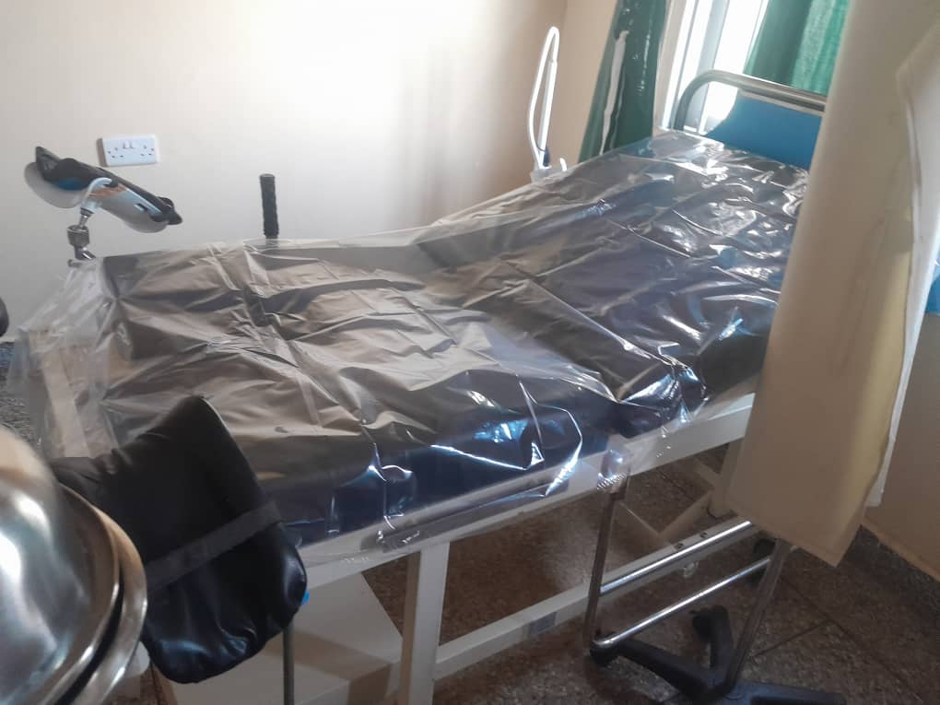
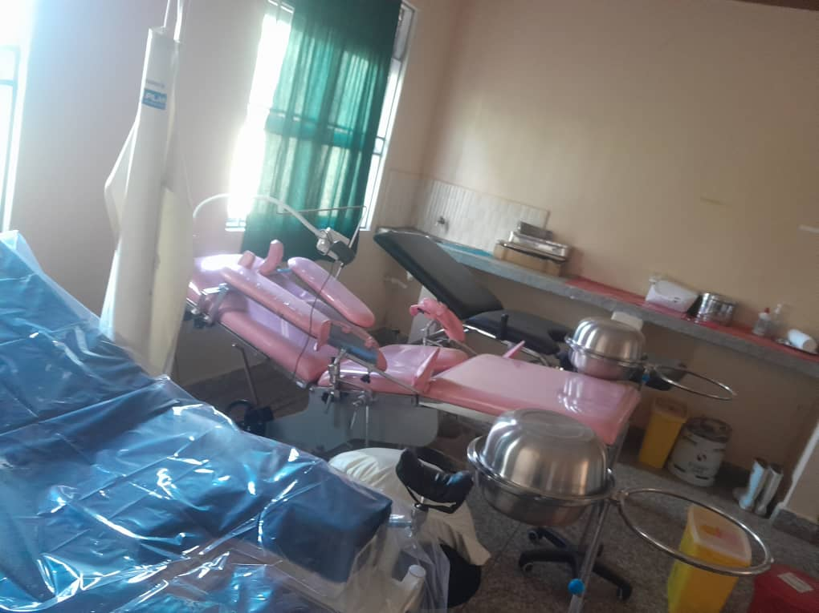
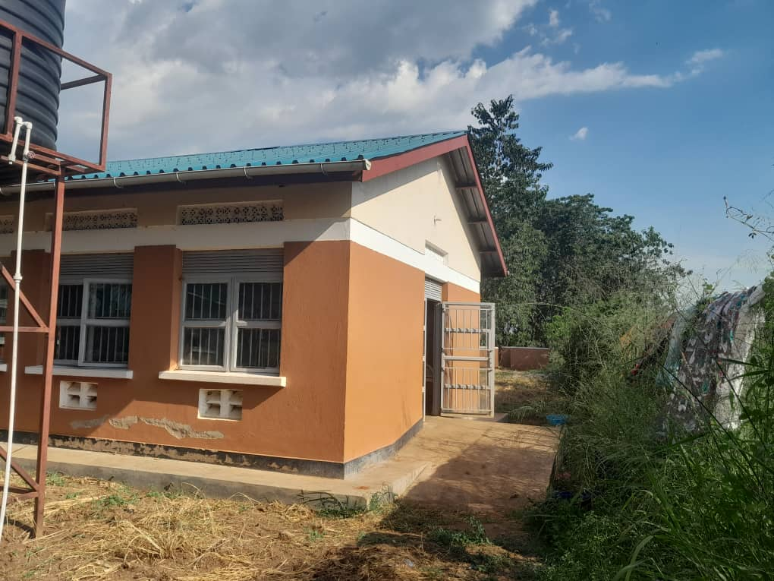
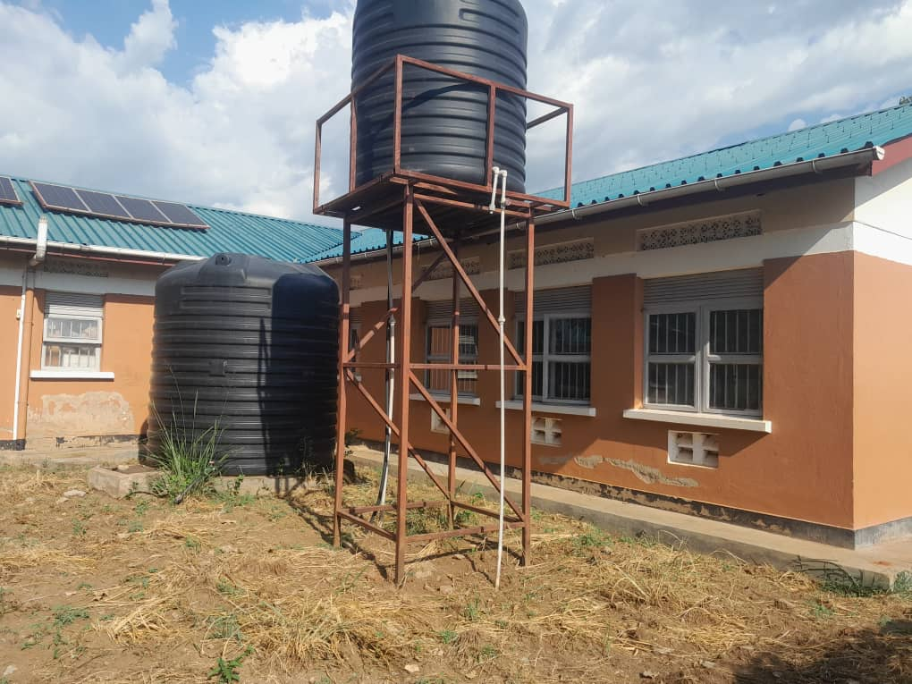
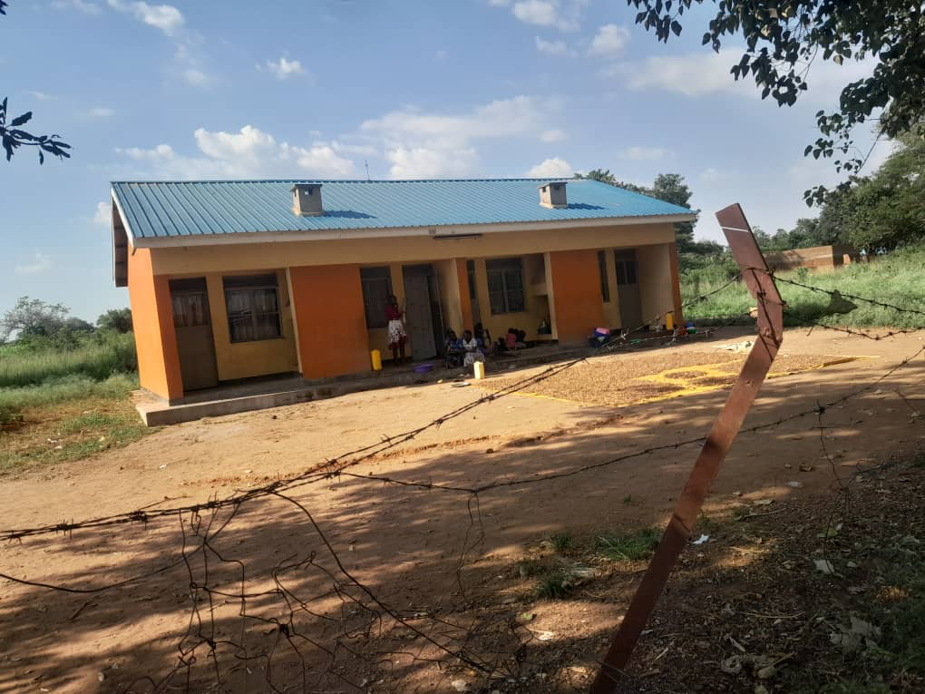
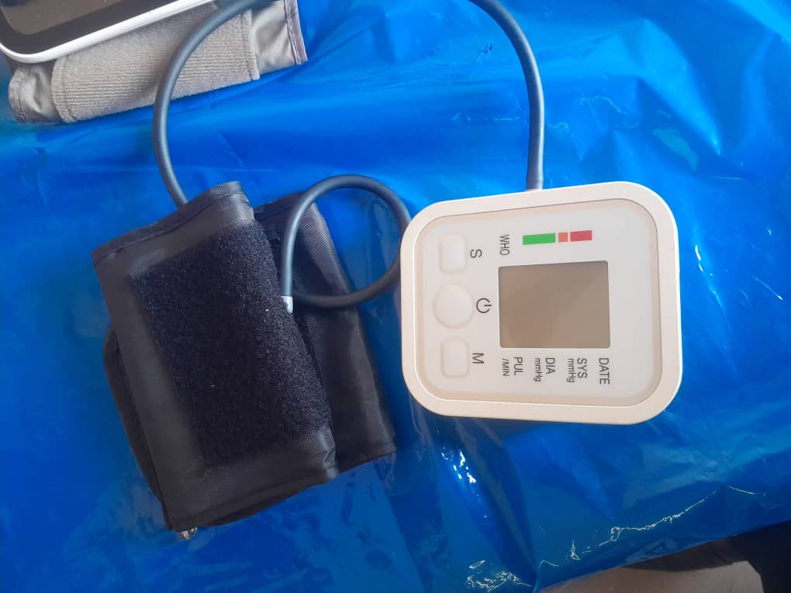
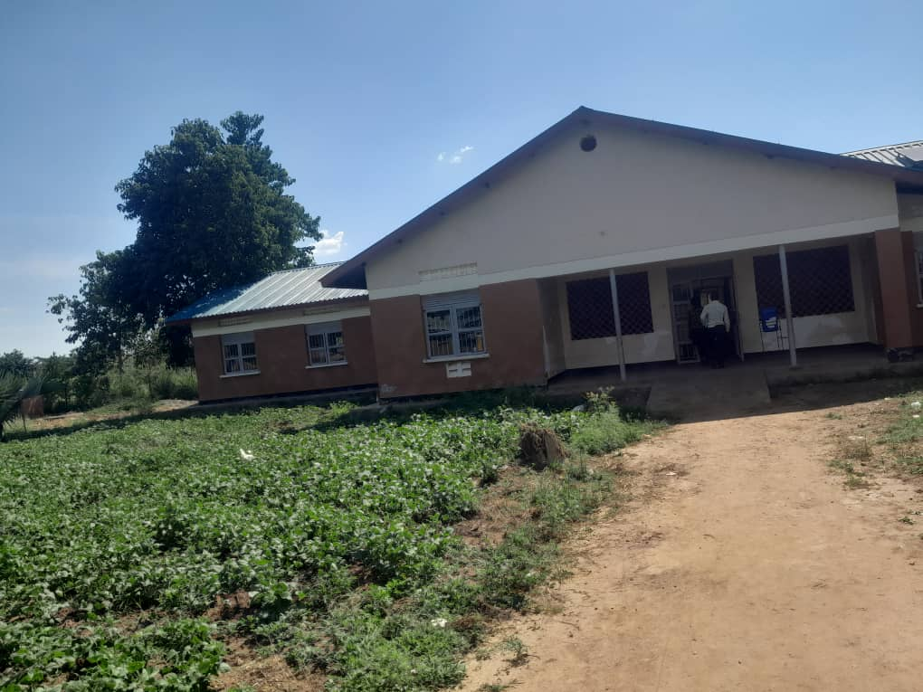
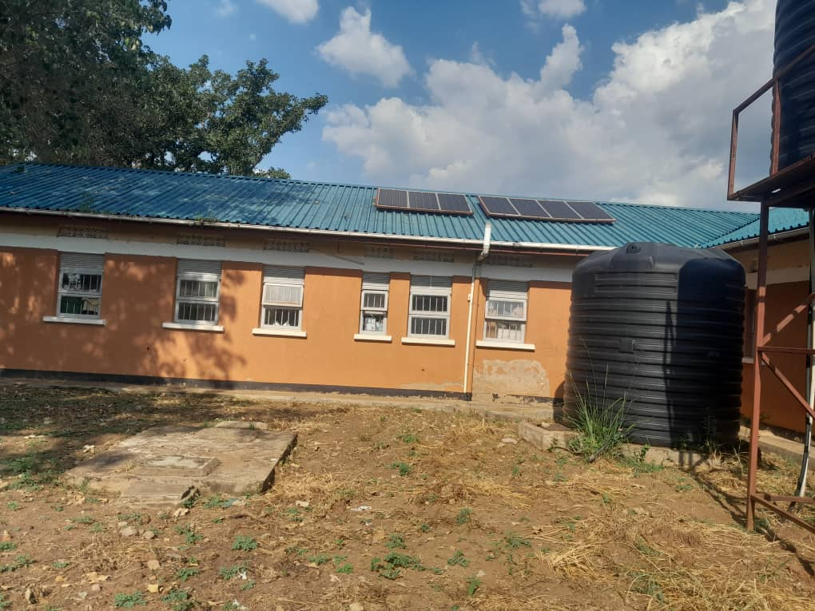
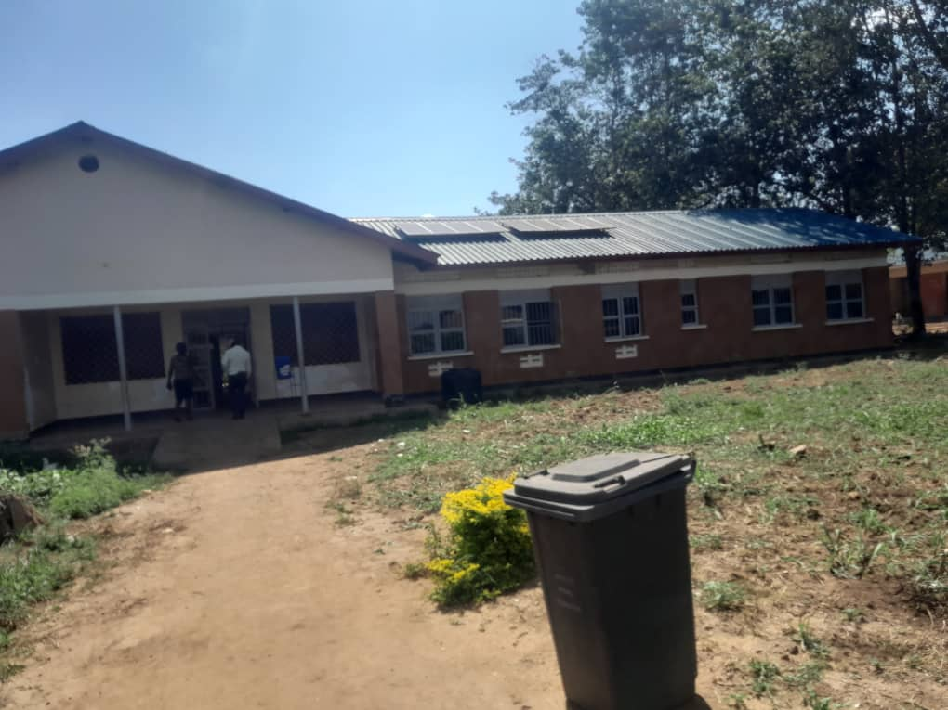
IMAGES FROM SOURCE
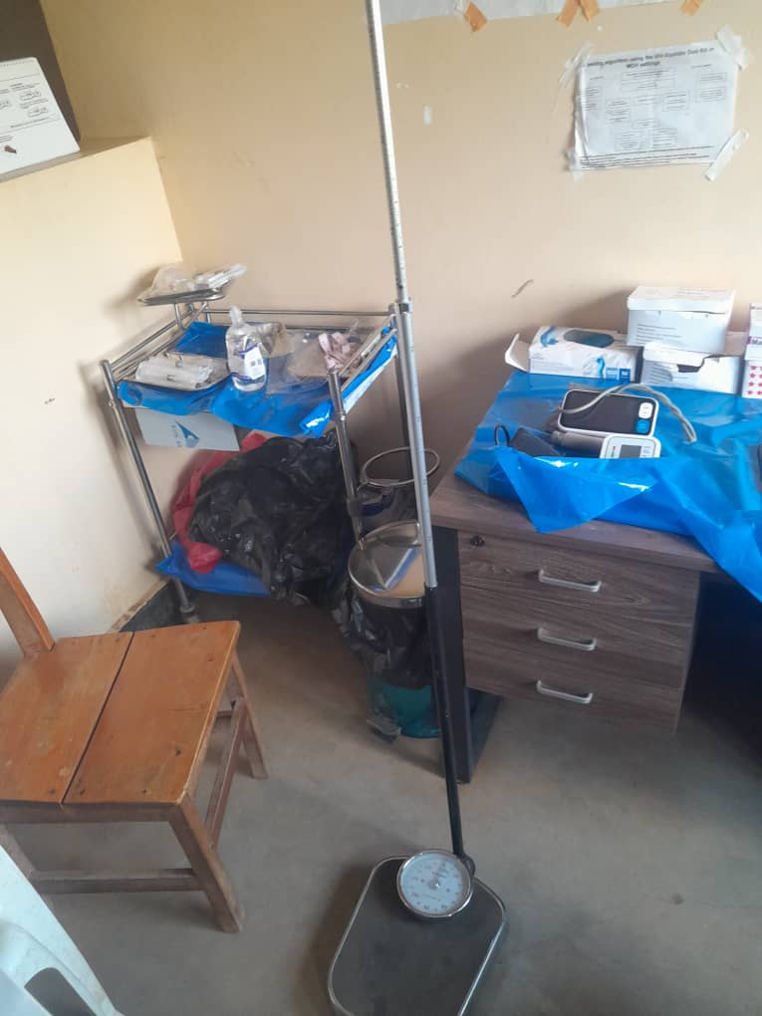
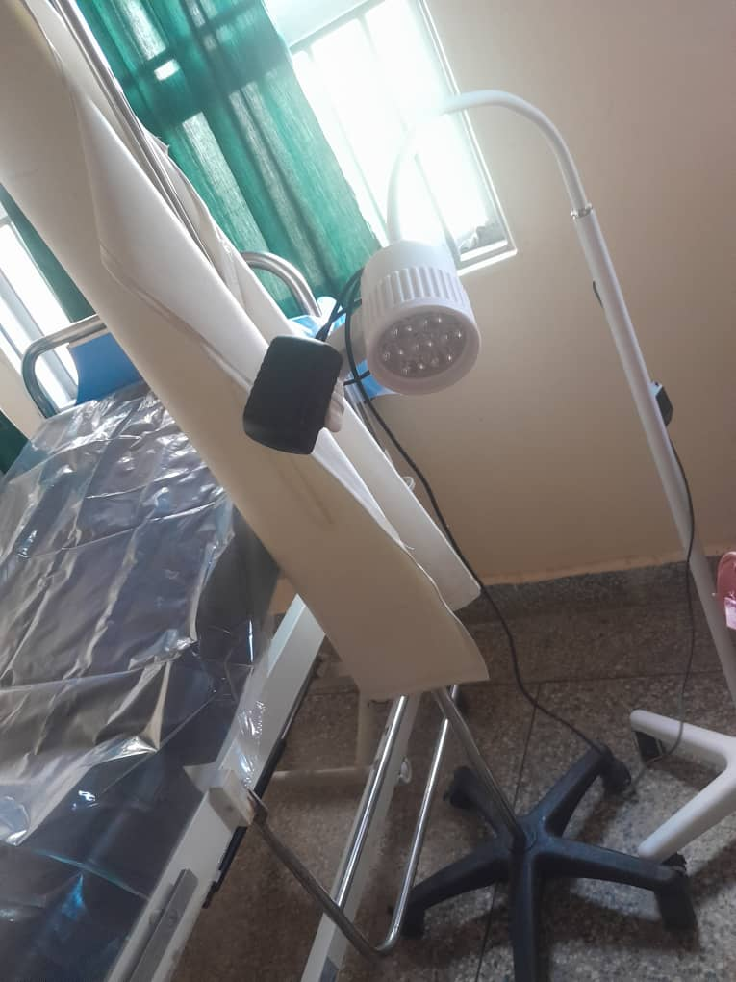
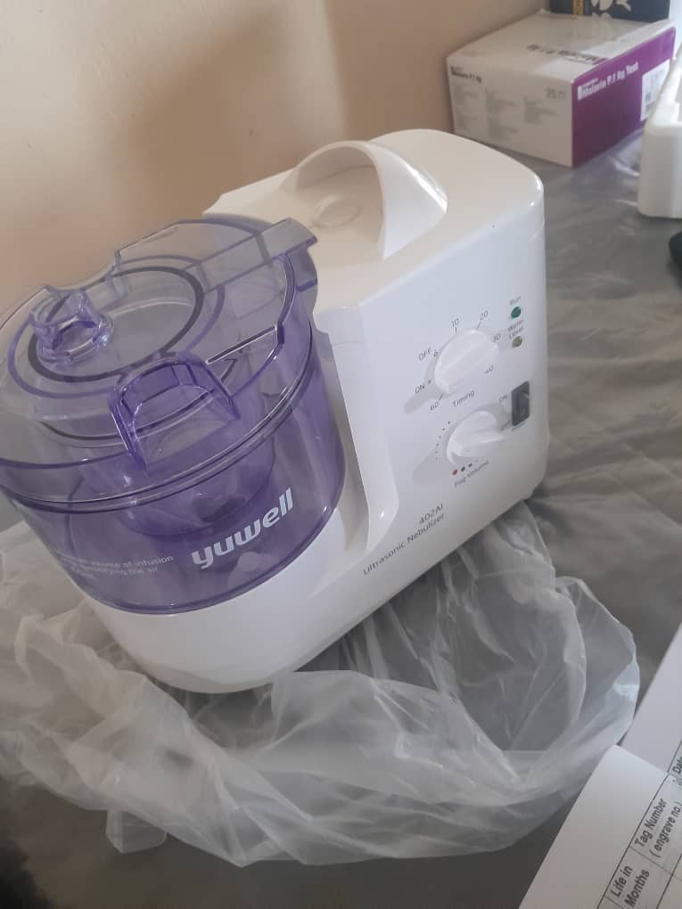
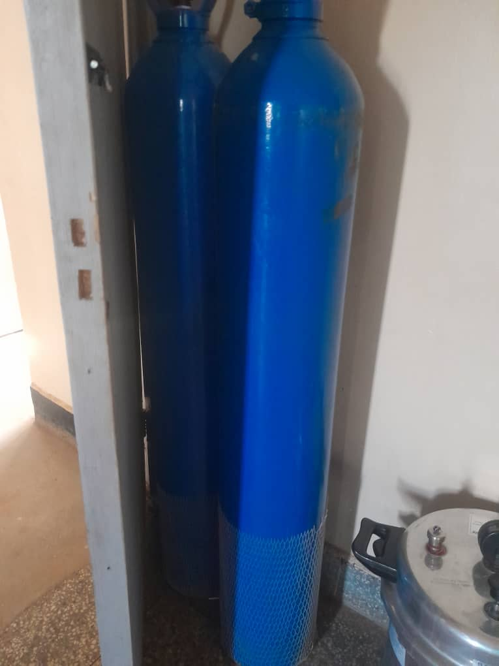
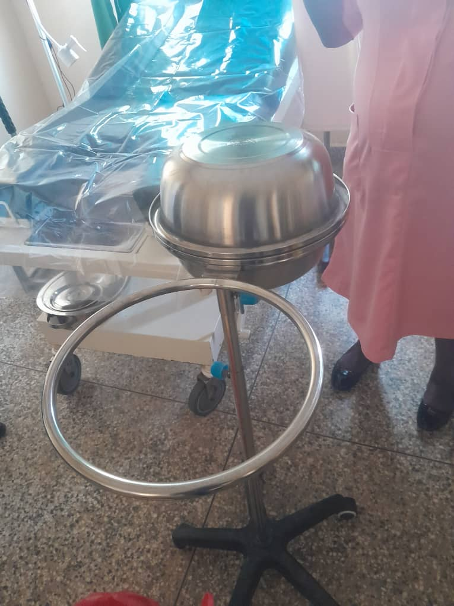
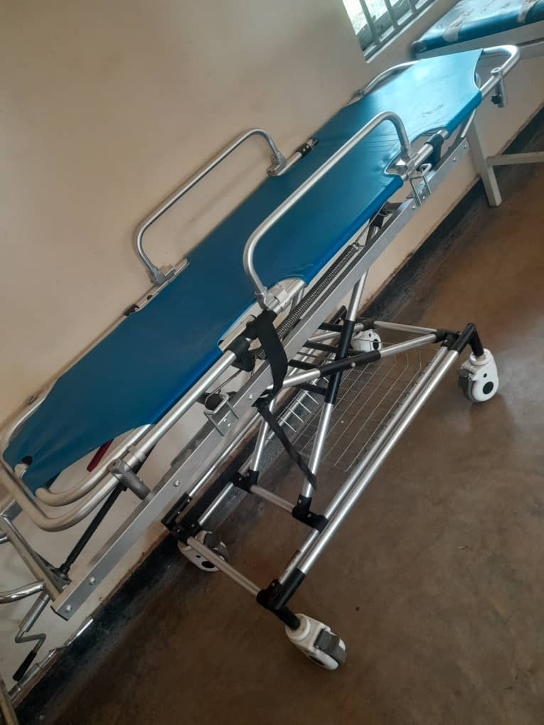
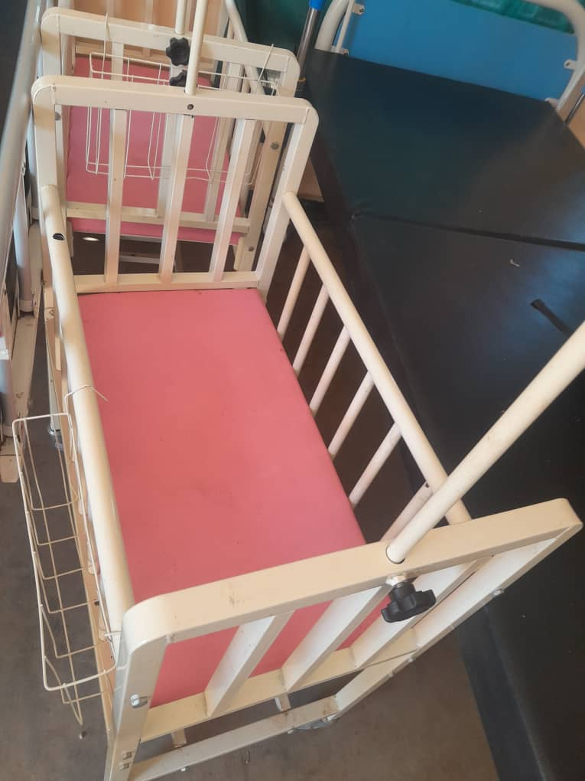
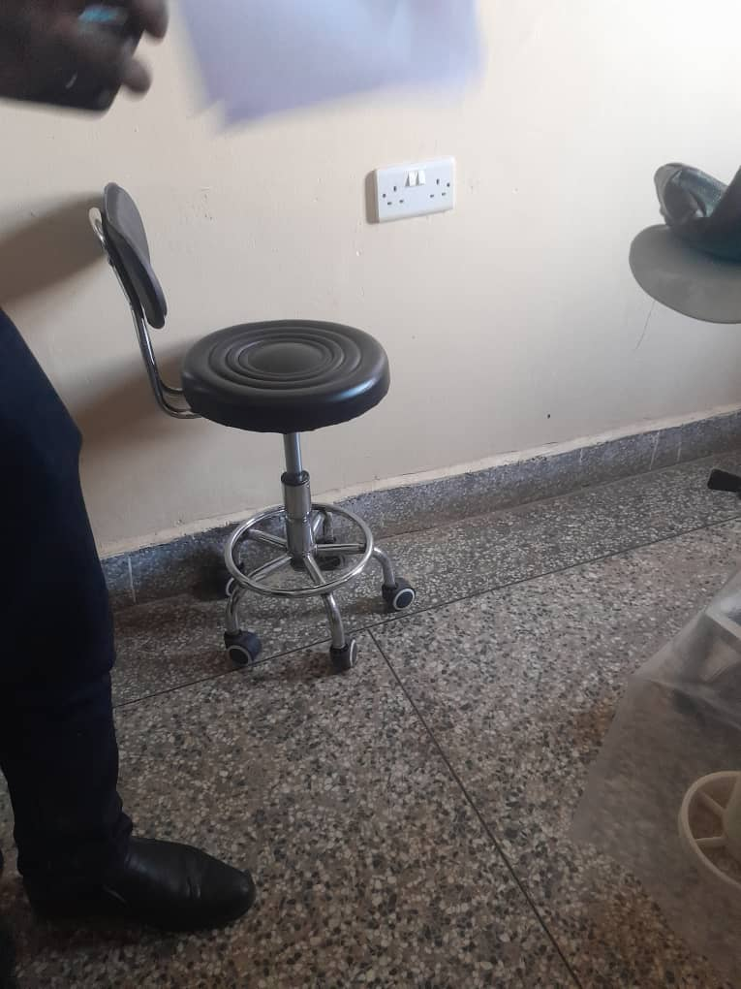
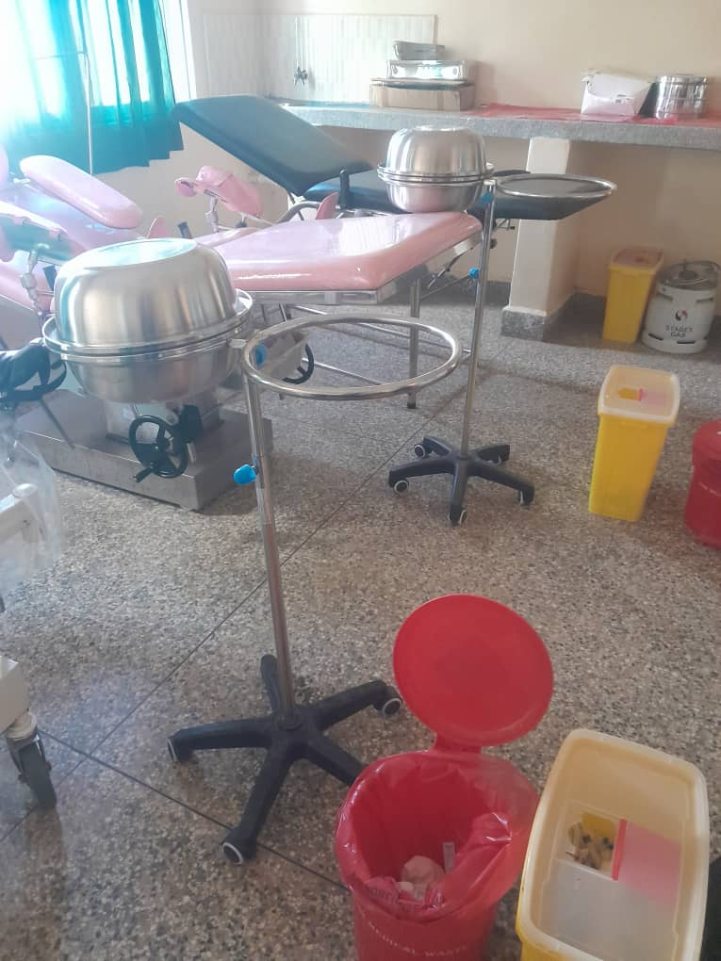
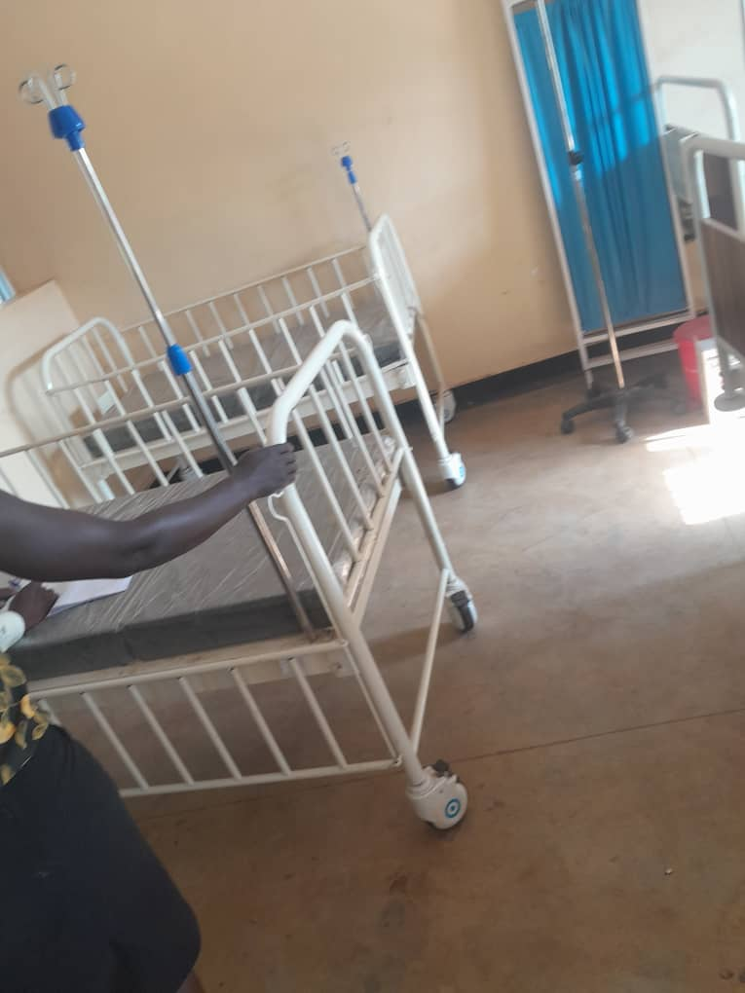
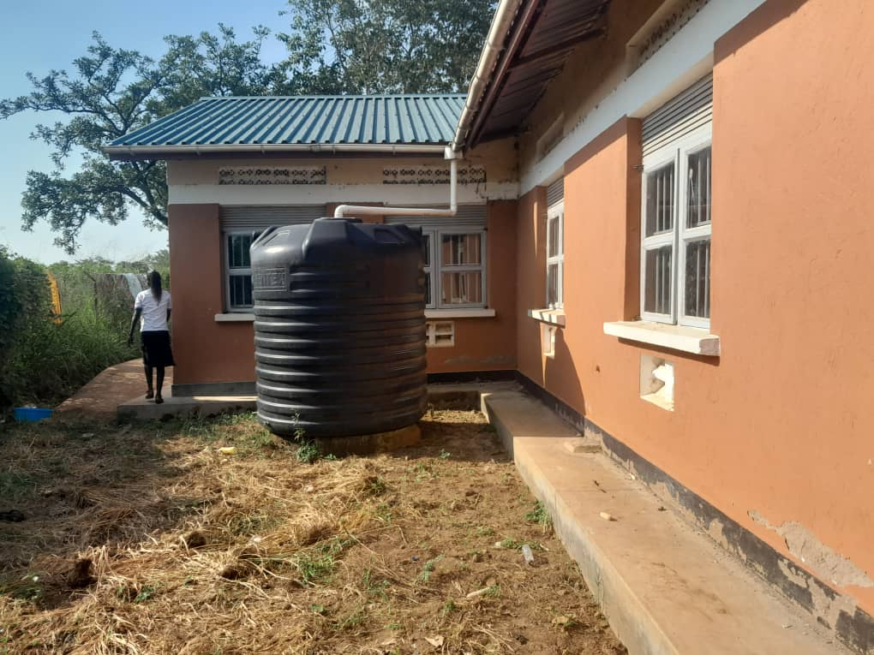

LAPONO SEED SCHOOL, LAPONO SUB COUNTY IN AGAGO DISTRICT
Information from the focal person in charge of the facility. He warmly welcomed the team and took the team through the asset and facilities, the school so far benefited from UGIFT Programme.
NB: the facility has no asset register for UGIFT assets. The work at the facility was substantially done.

FINDINGS
- 3 Blocks each with 2 class rooms
- 1 Science laboratory block with two labs i.e. Biology and Chemistry
- 1 ICT block with two labs i.e. Computer room and Library room
- 6 Staff house units with 6 staff Kitchen units
- 2 Toilets at staff quarters each with 2 stanzas
- 1 staff school toilet with 2 stanzas
- 2 student toilets for both girls and boys each with 5 stanzas
- 1 big gas Cylinder
- 1 school pitch
- Not fenced
FURNITURE
- 120 Desks, 20 per class
- 20 Tables
- 24 book shelves
- Stools for laboratories
- 12 office chairs
- 303 Wooden and Metallic chairs
- 6 War drops
ICT DEPARTMENT
- 20 CPU’s
- 20 Monitors
- 20 uninterrupted power supply
- 1 Computer Server
- 1 Projector
- 1 Camera
CHALLENGES
- Have no stools in the labs
- The facility is not fenced
- Have no reliable power source/Supply
- Pathways and compound not well-grounded

NB: Recommendations are opposite of the challenges.

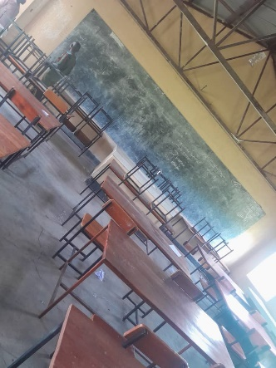
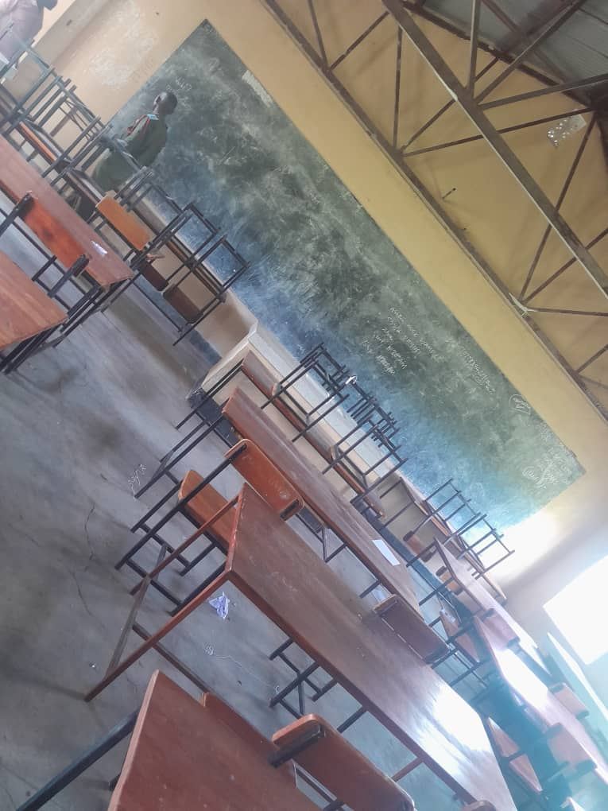
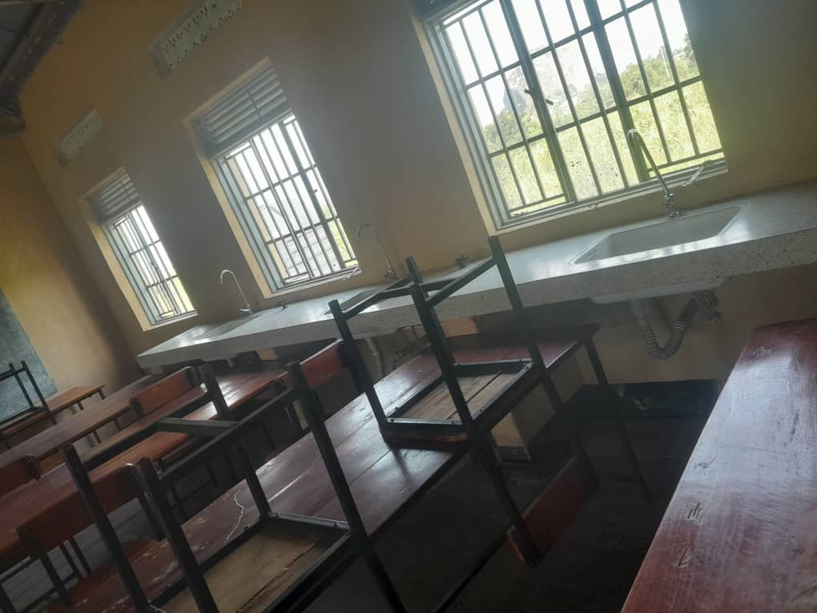
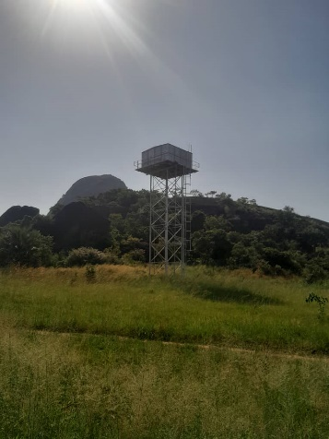
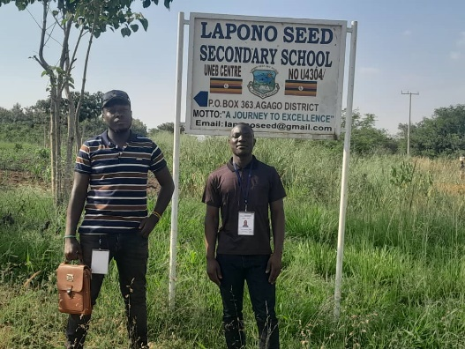
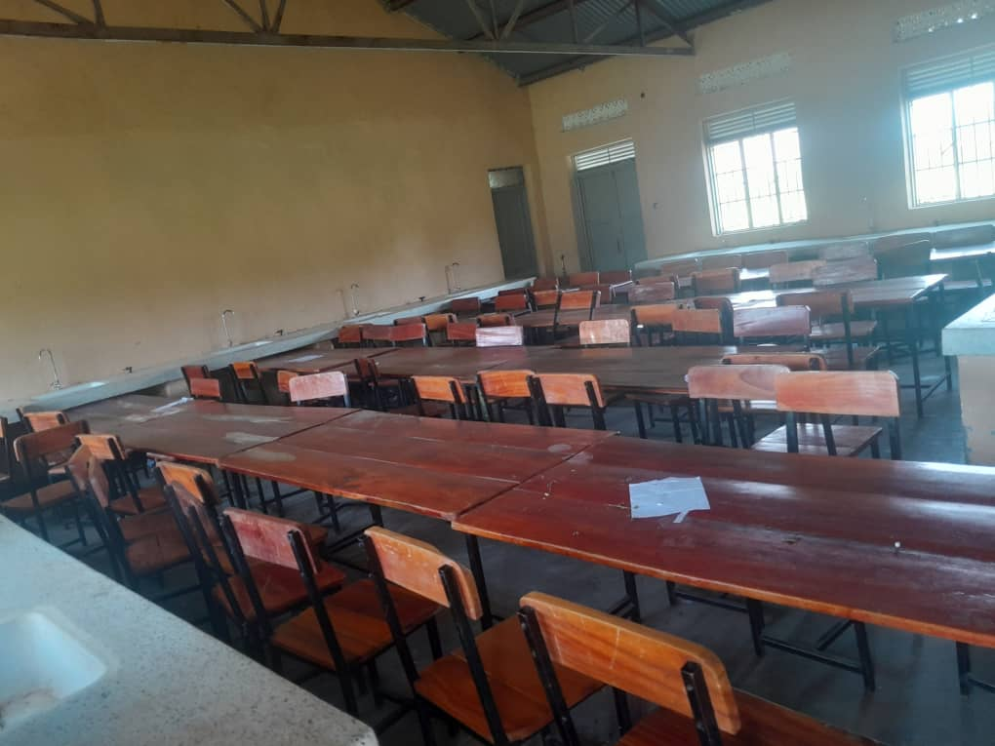
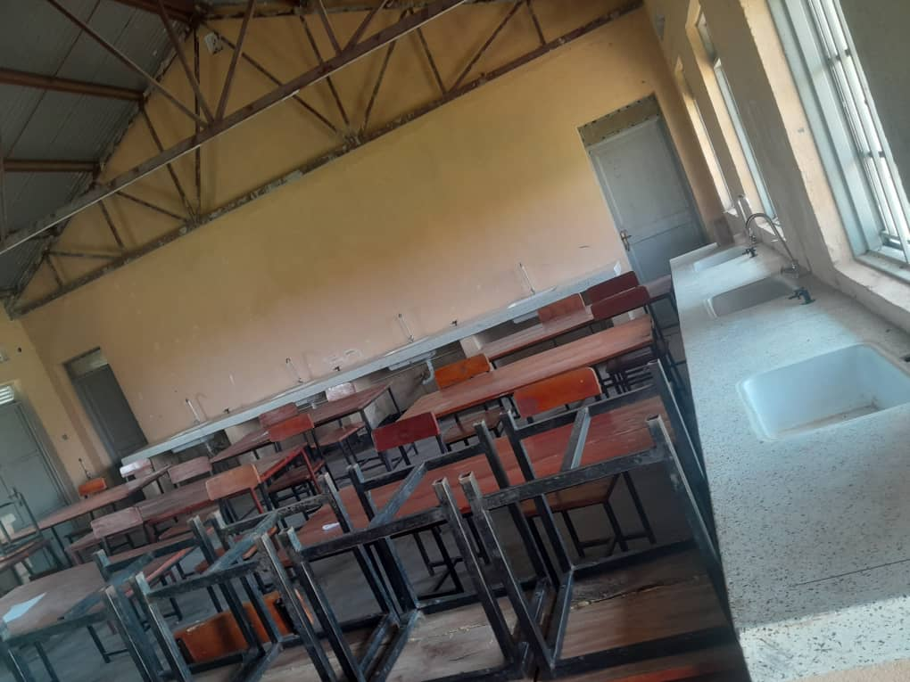
IMAGES FROM SCHOOL
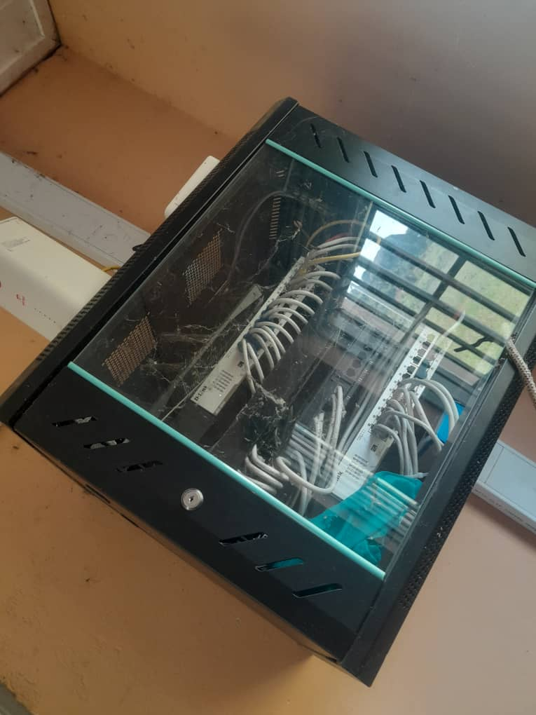
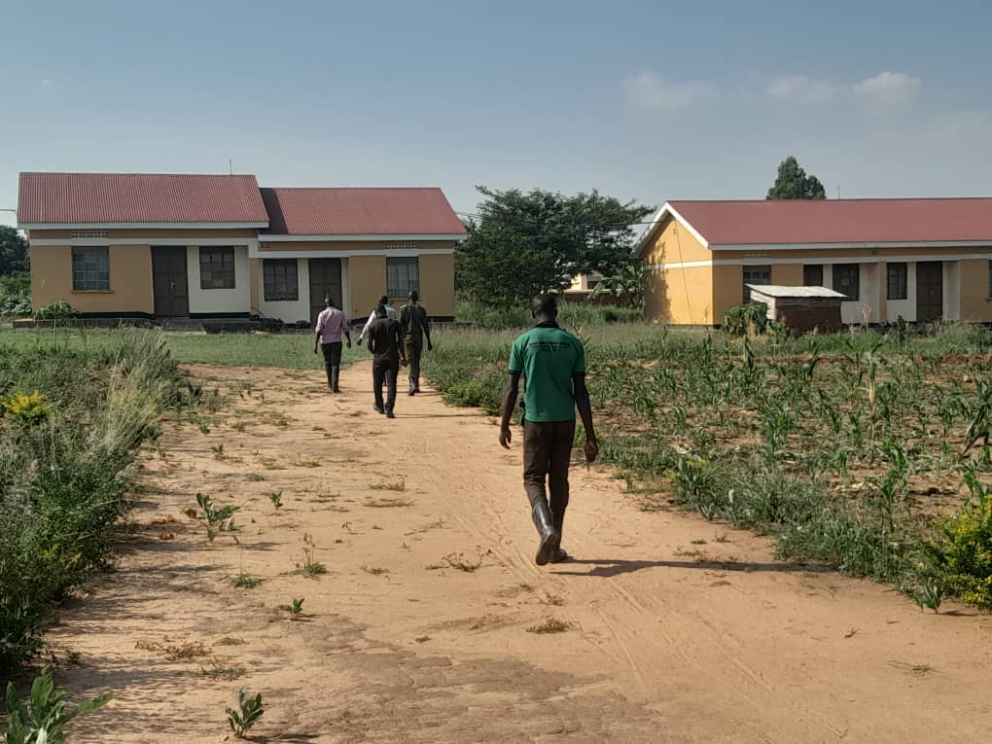
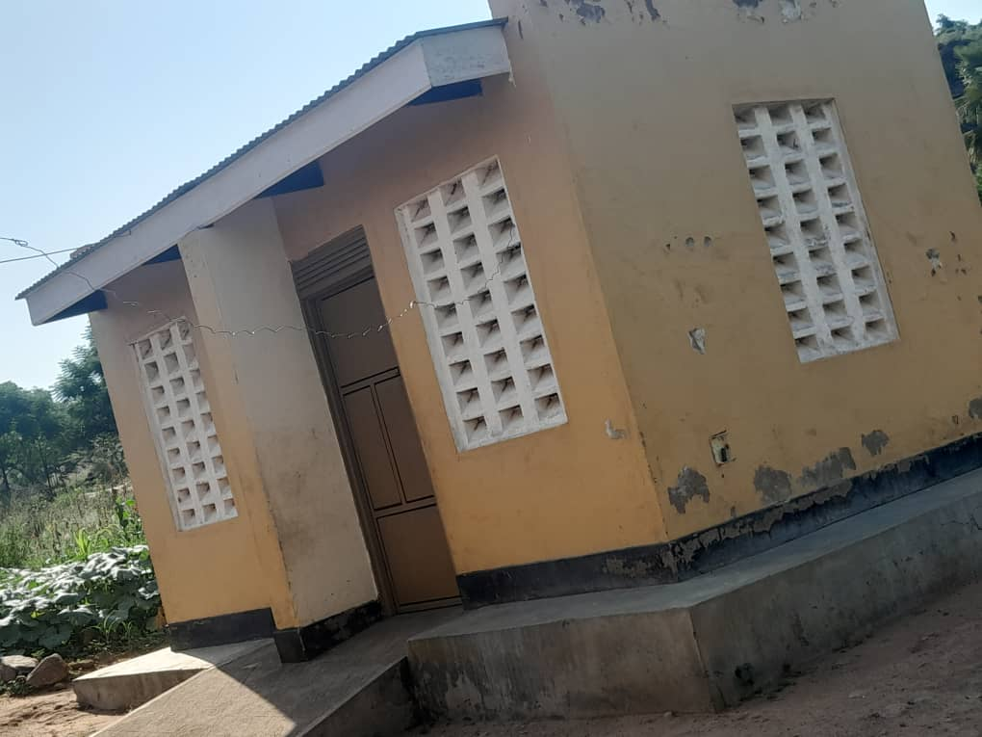
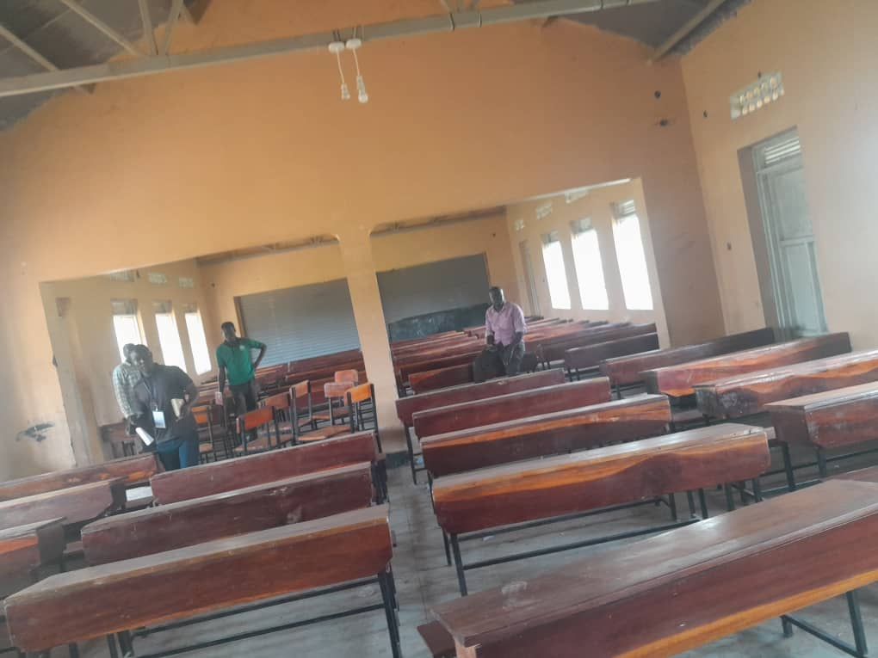
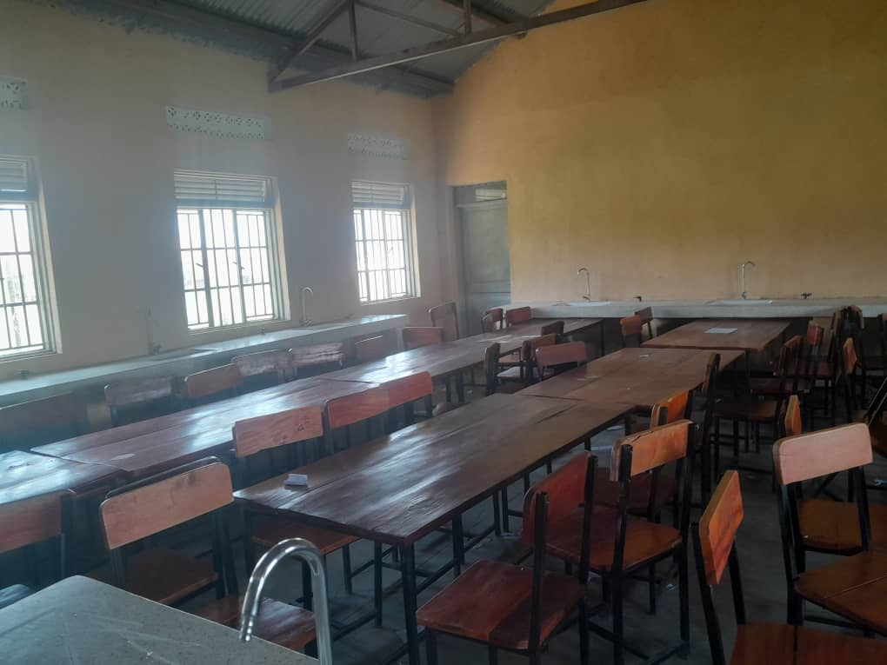
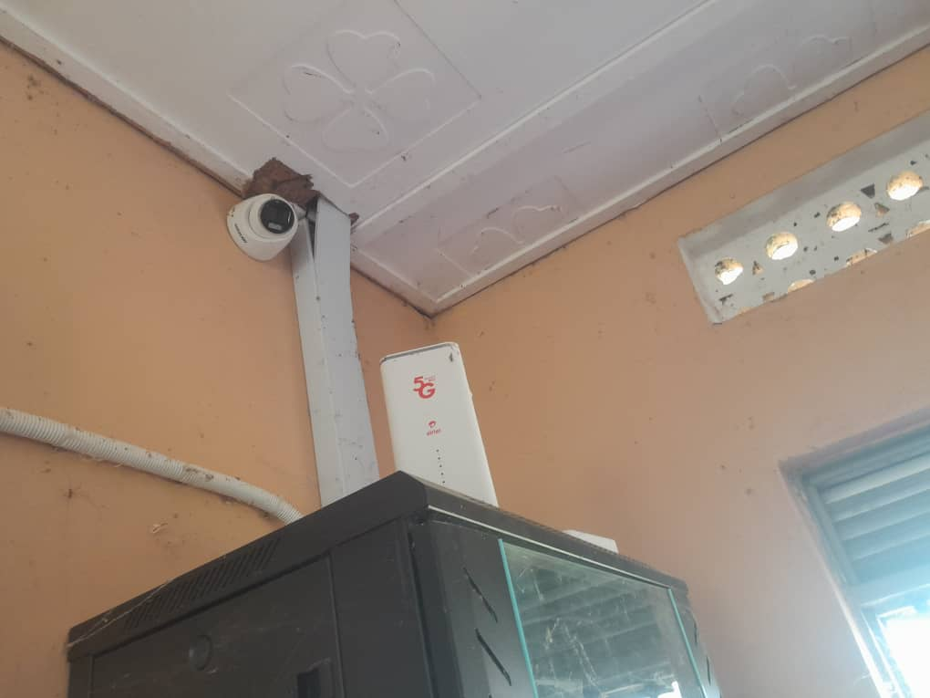
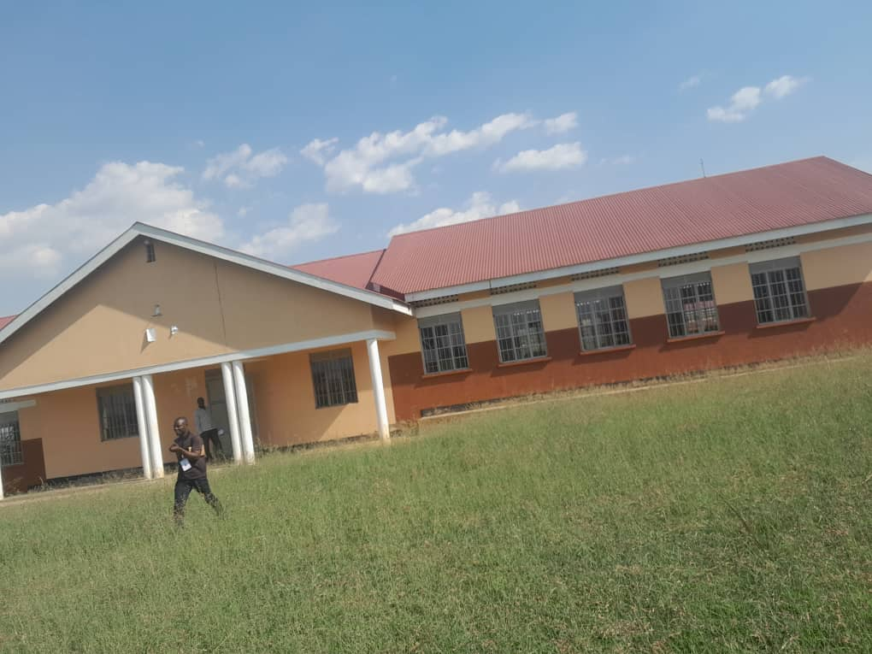
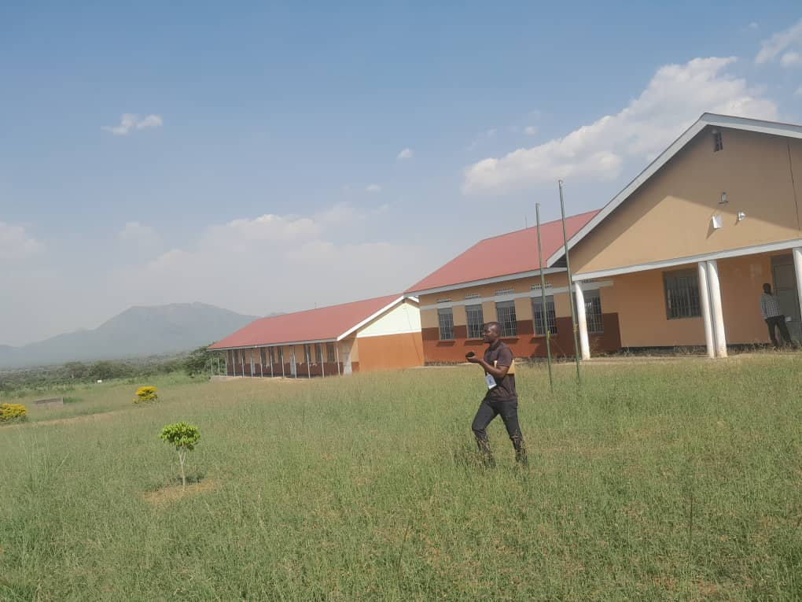
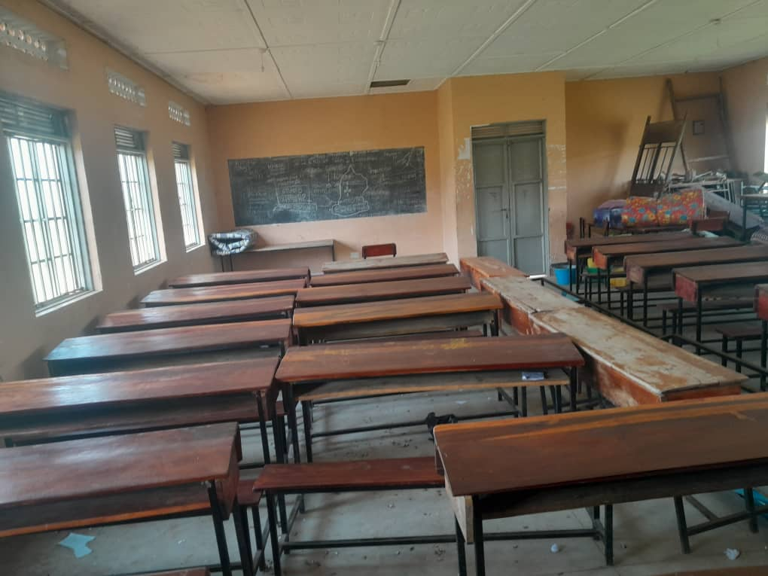
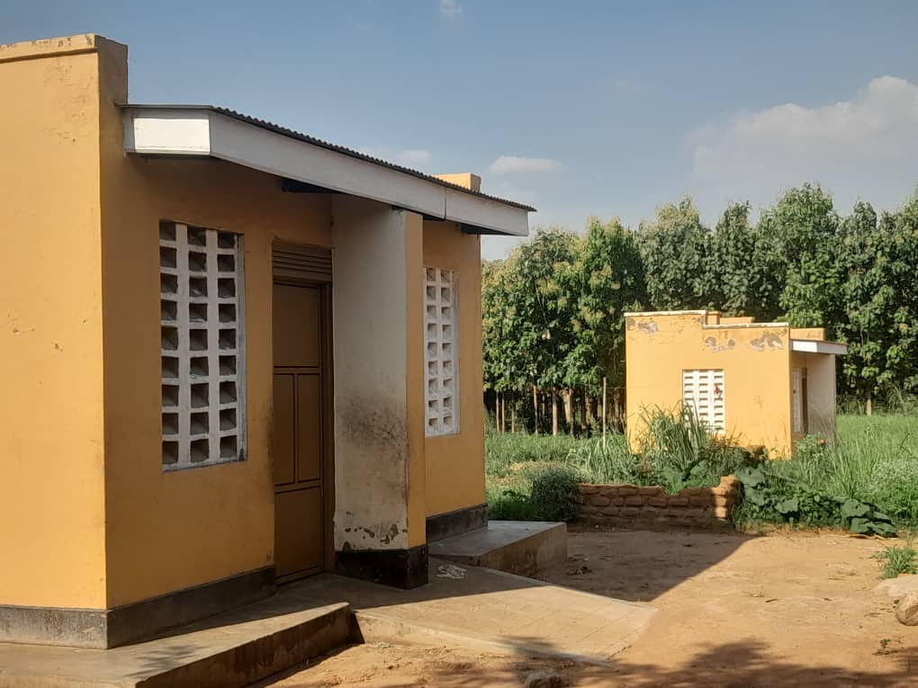
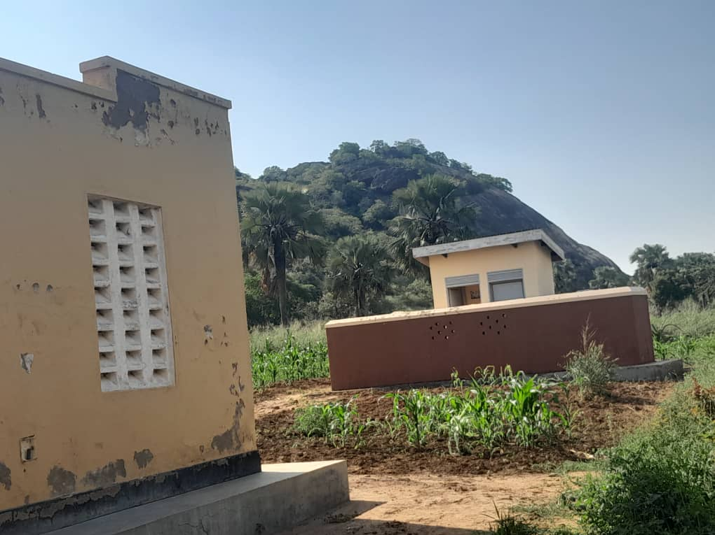

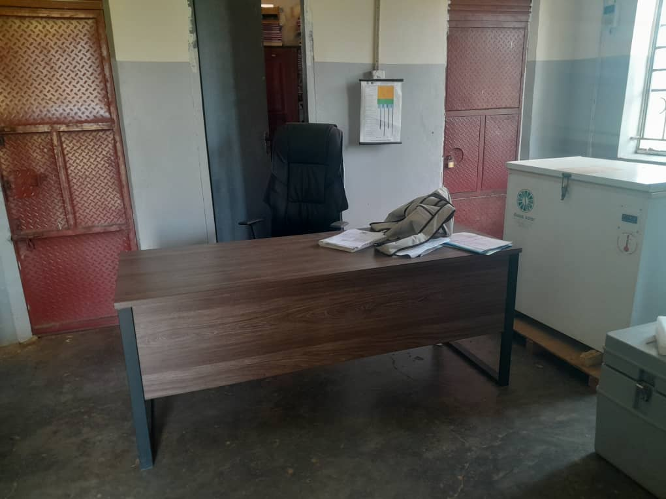
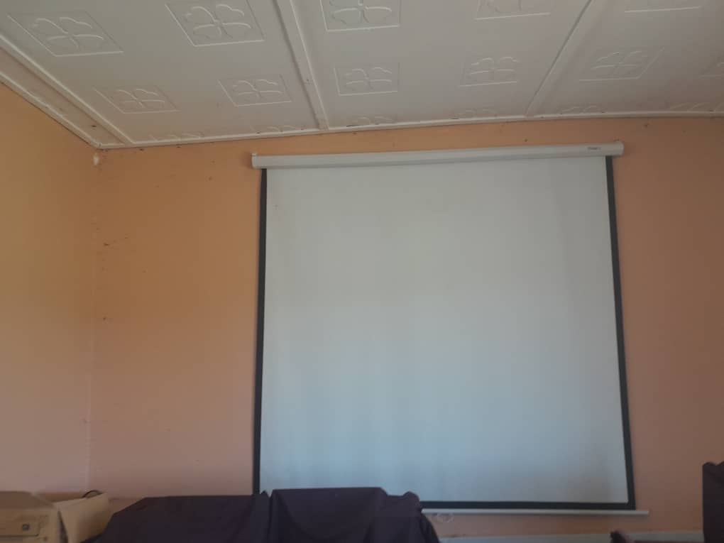
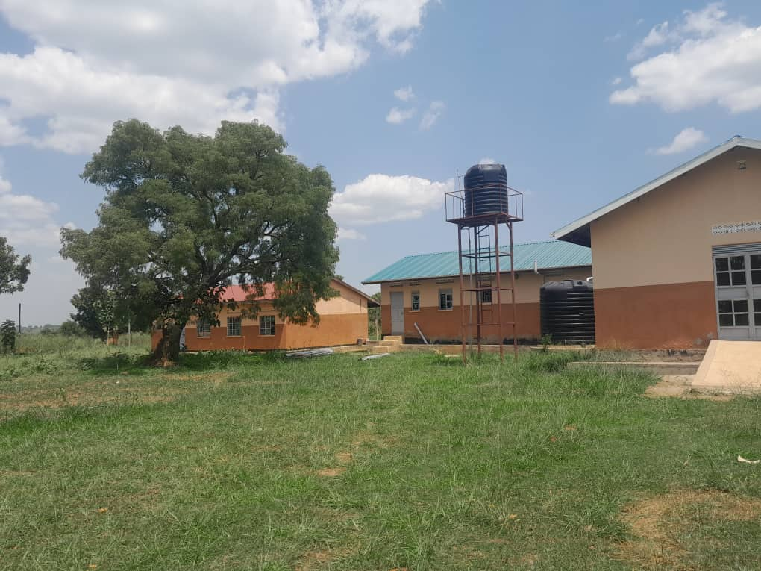
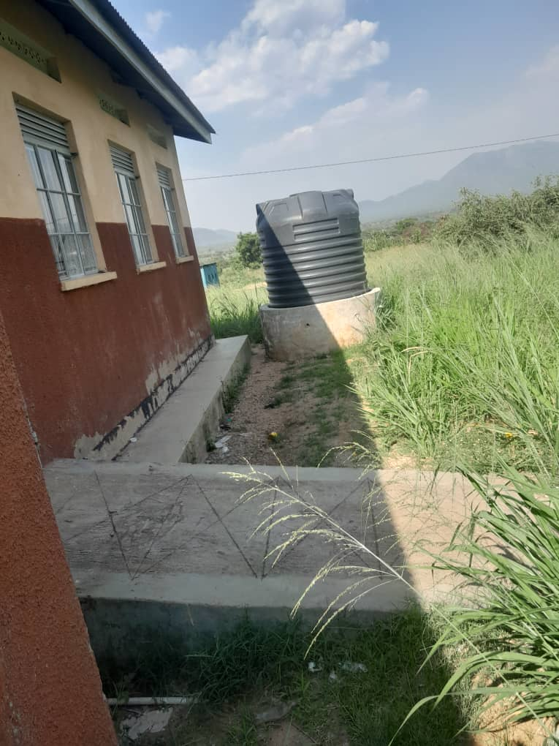
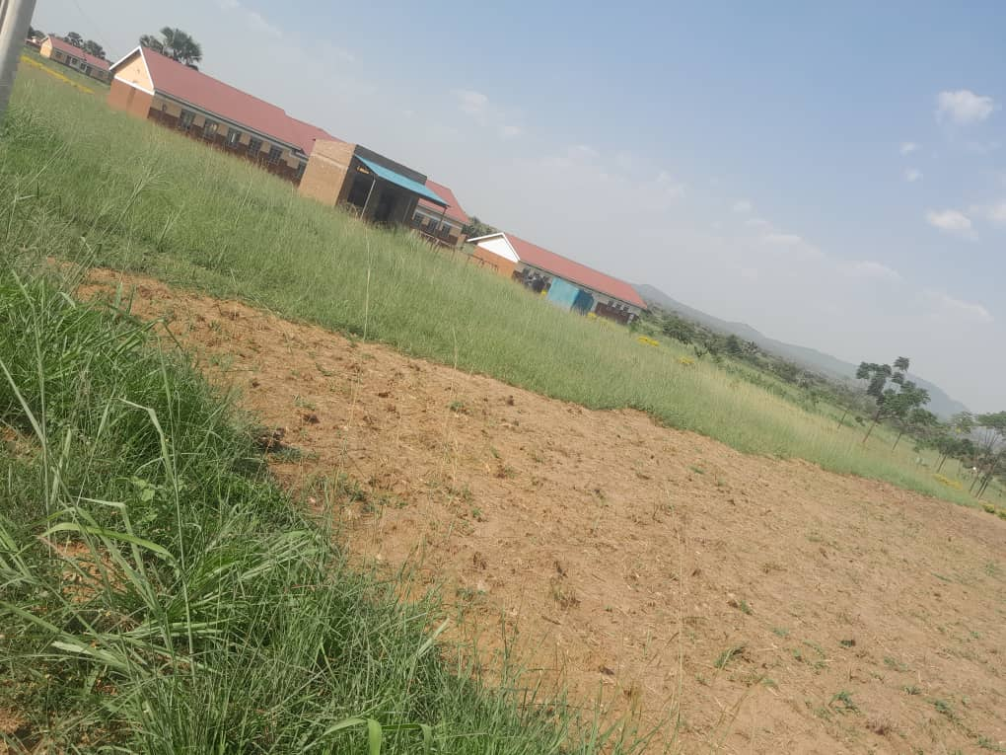
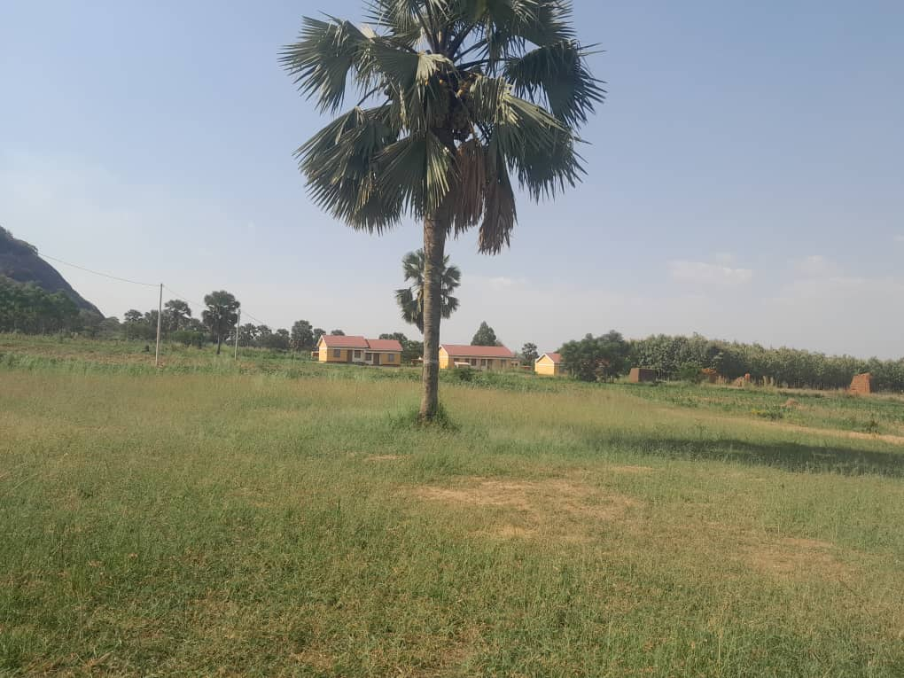
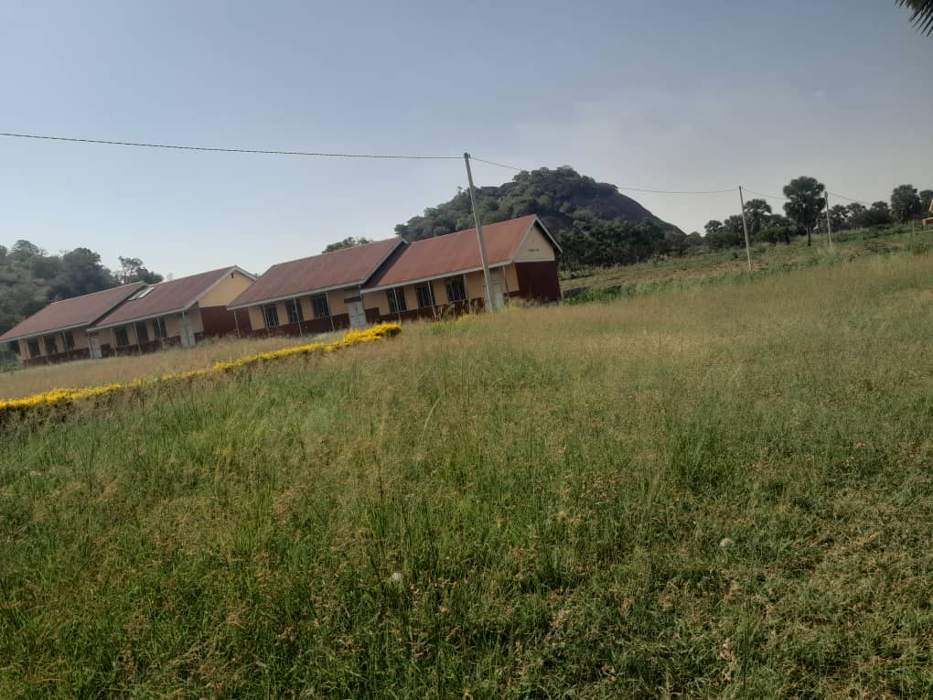
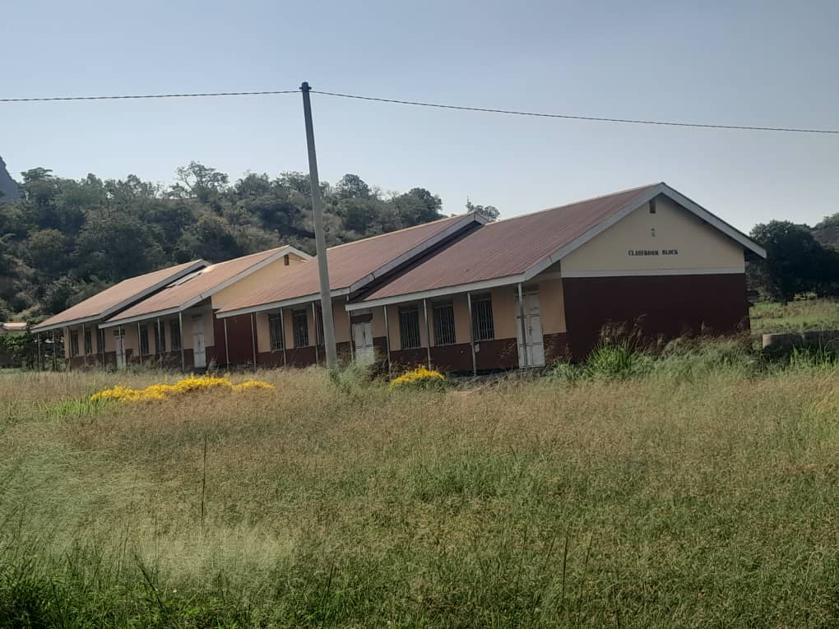
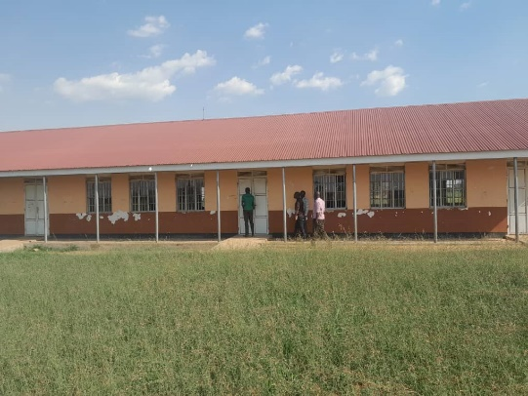
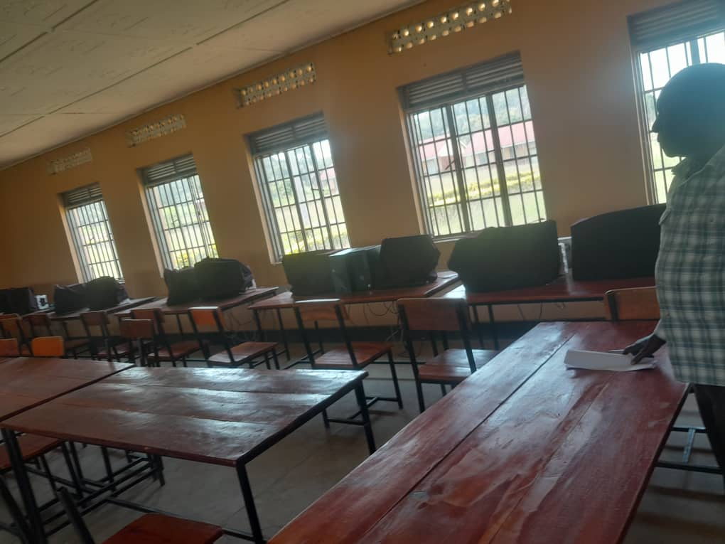
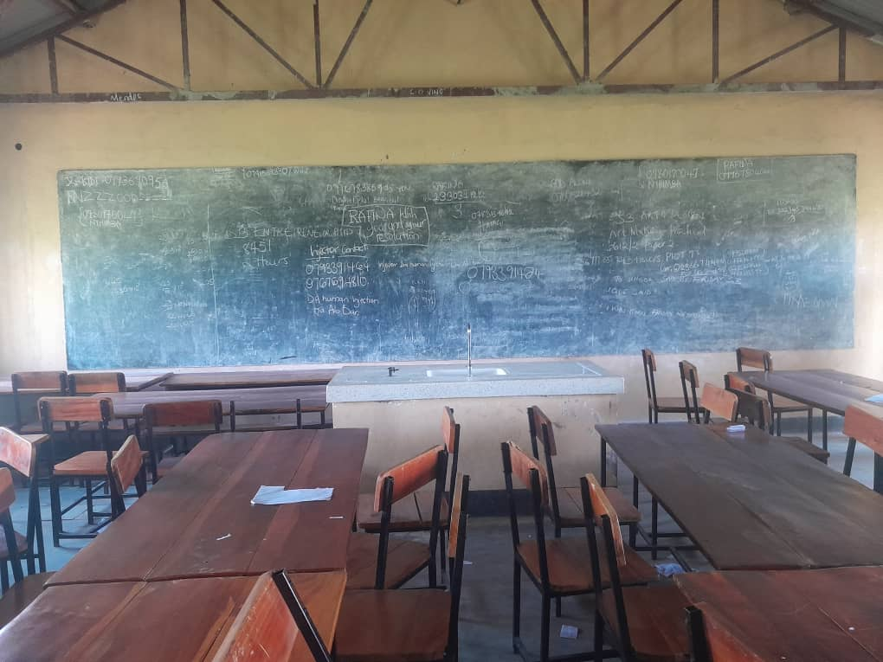

LAYITA HEALTH CENTRE II, LAYITA SUB COUNTY – AGAGO DISTRICT
Information from the focal person in charge of the LAYITA HEALTH CENTRE III
- The in charge warmly welcomed the team and proceeded and went ahead to tell the team of what the facility has benefited from UGIFT Programme
- He said the Layita Health Centre III only benefited with patient beds with mattresses from UGIFT Programme
- This information is evidenced by the photos attached on the report.

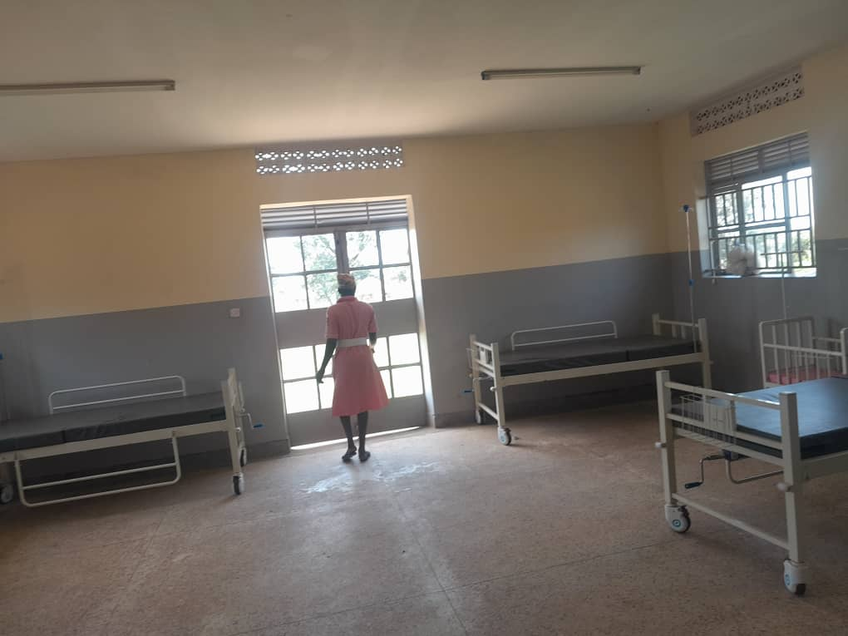
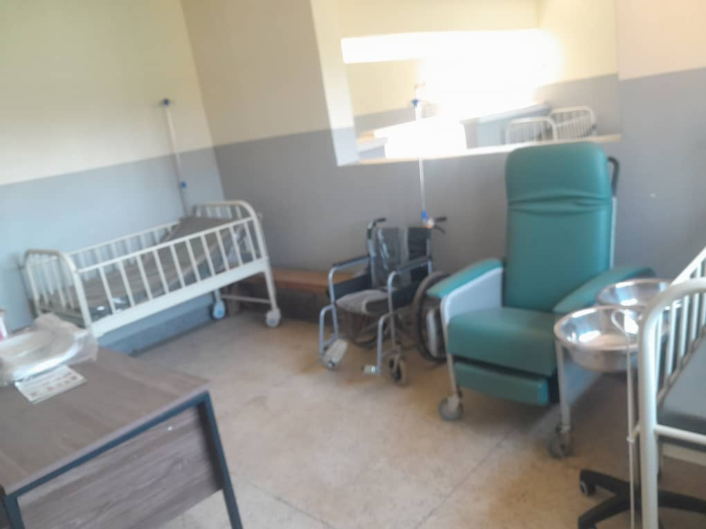
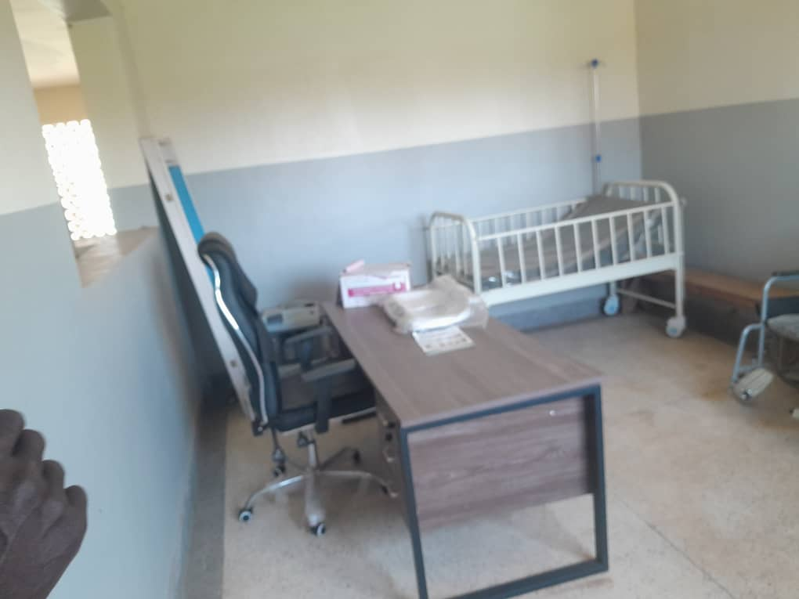
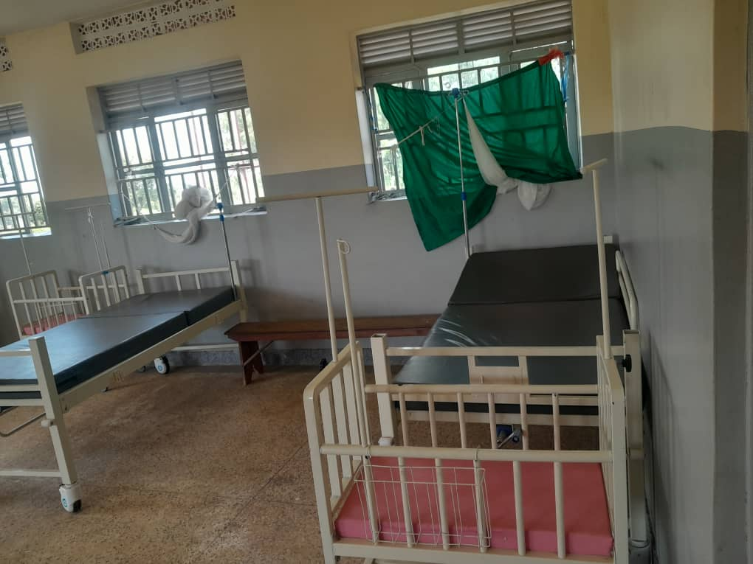
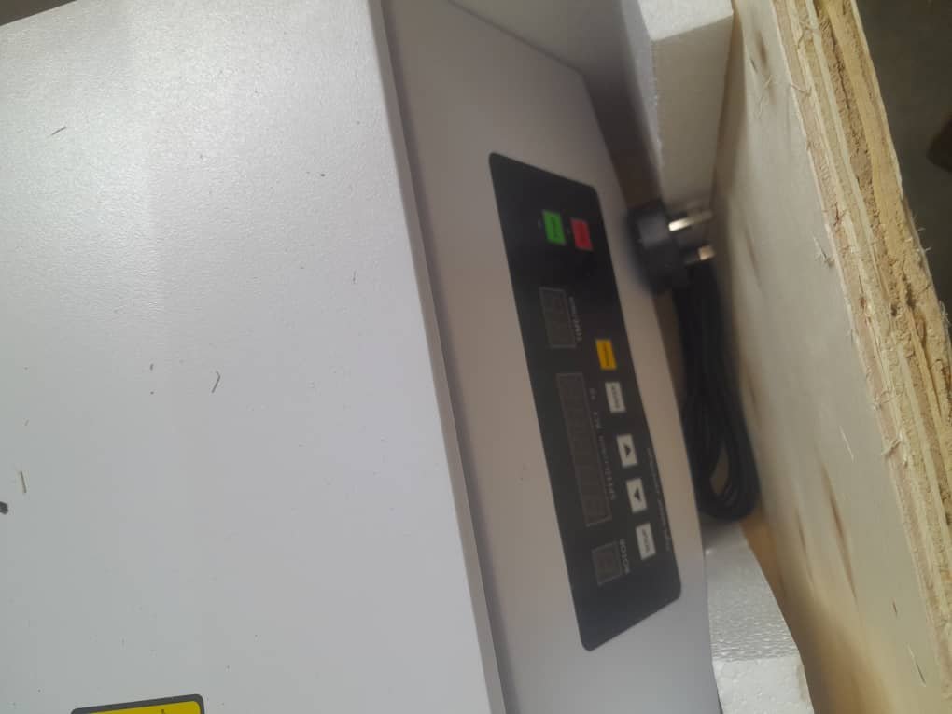
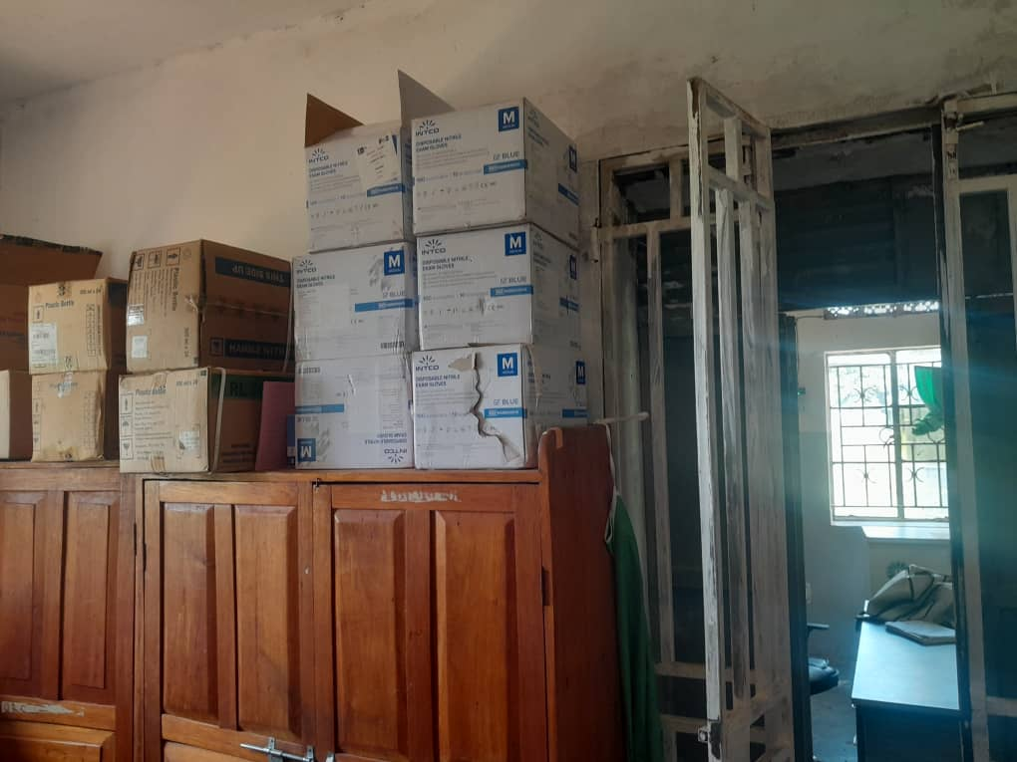
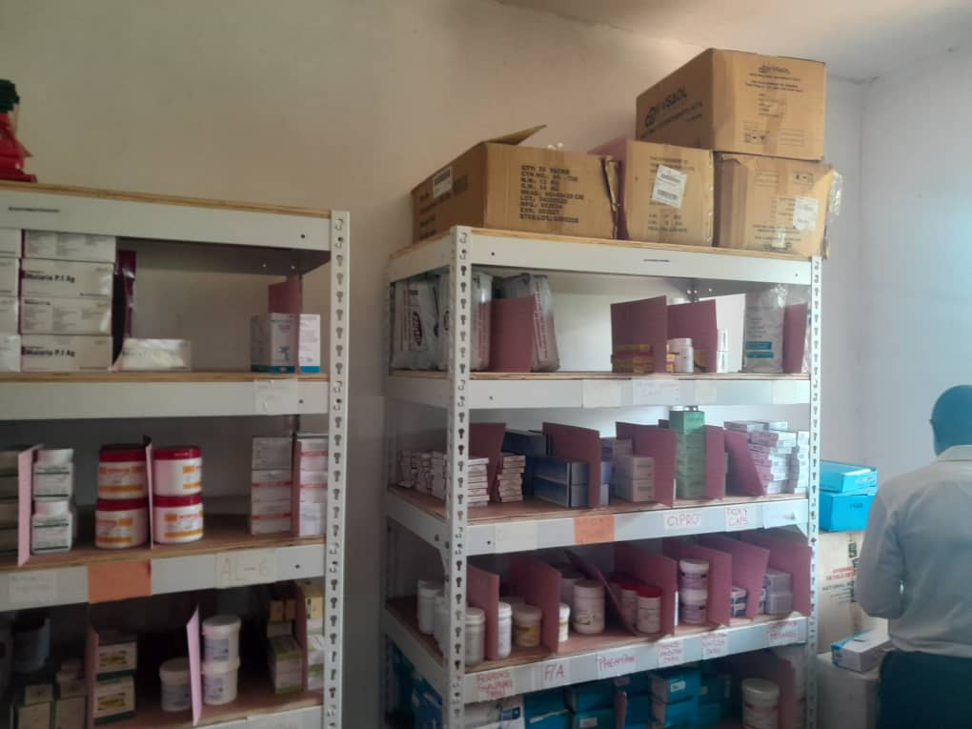
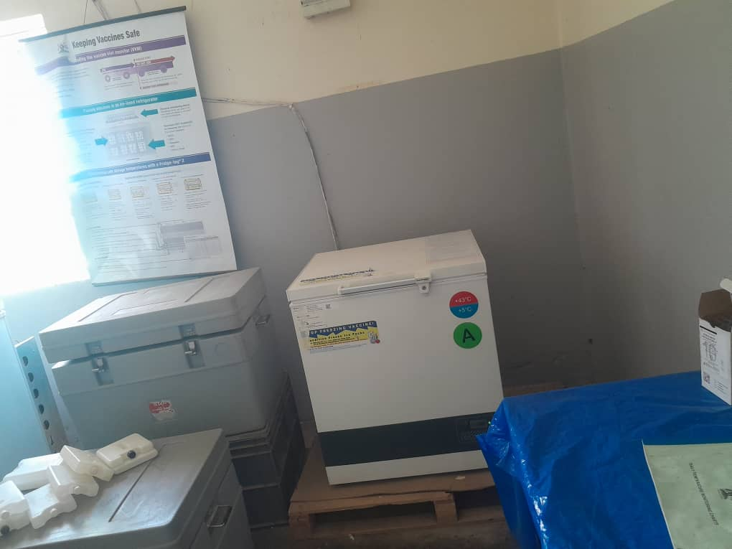
PHOTOS

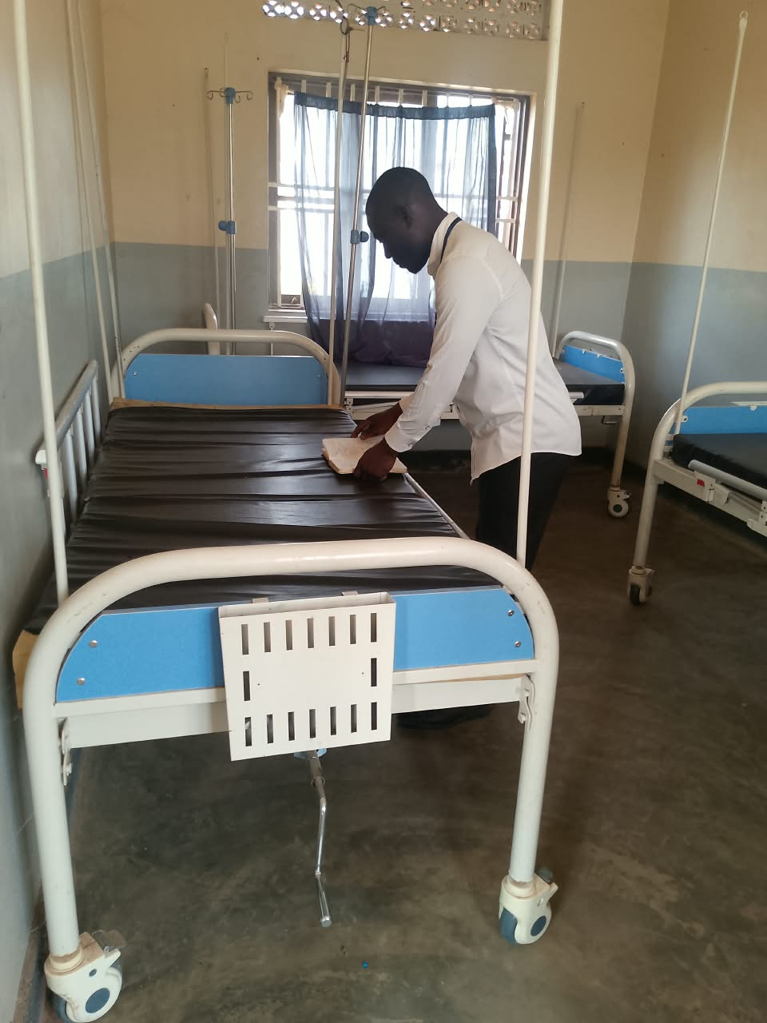
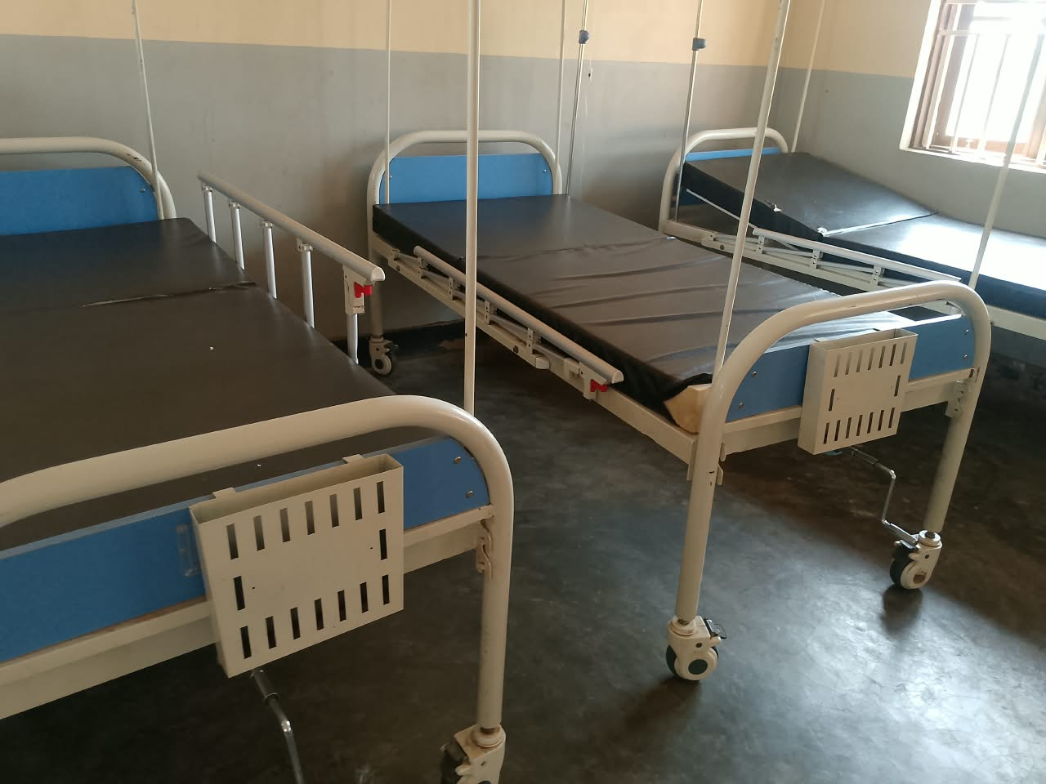
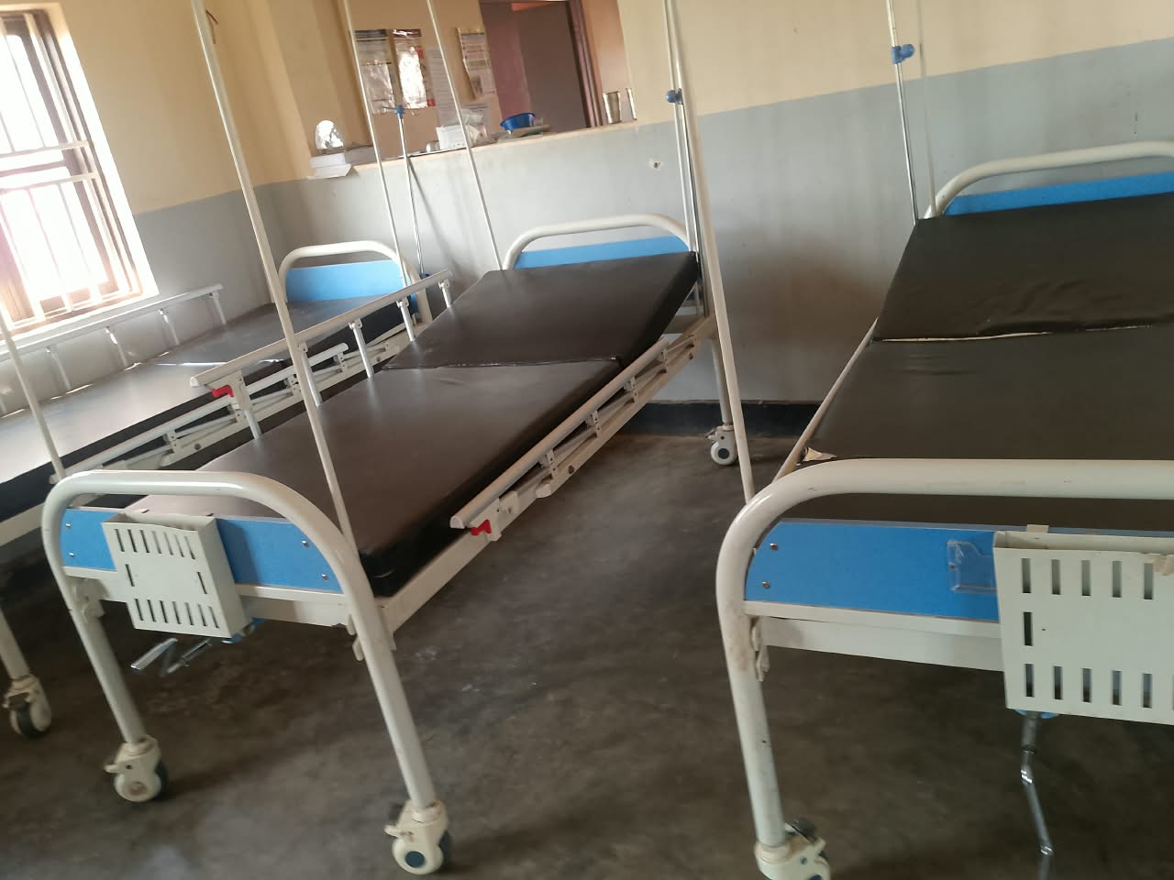
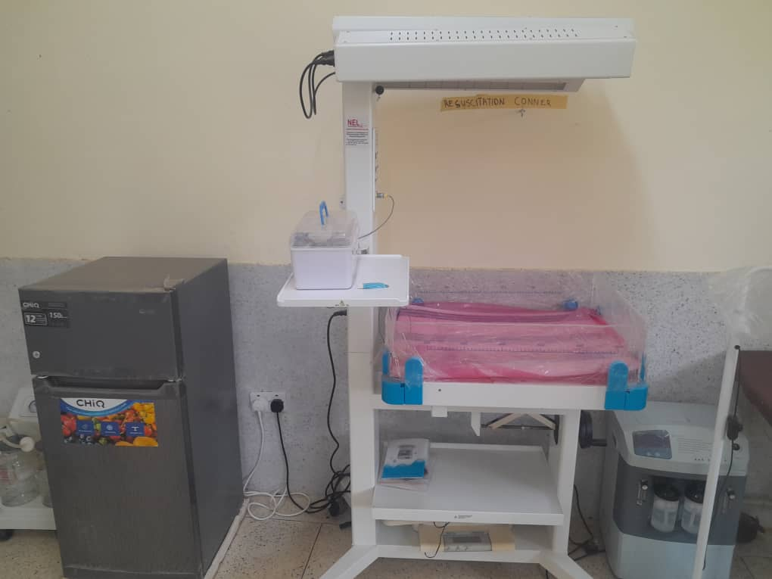
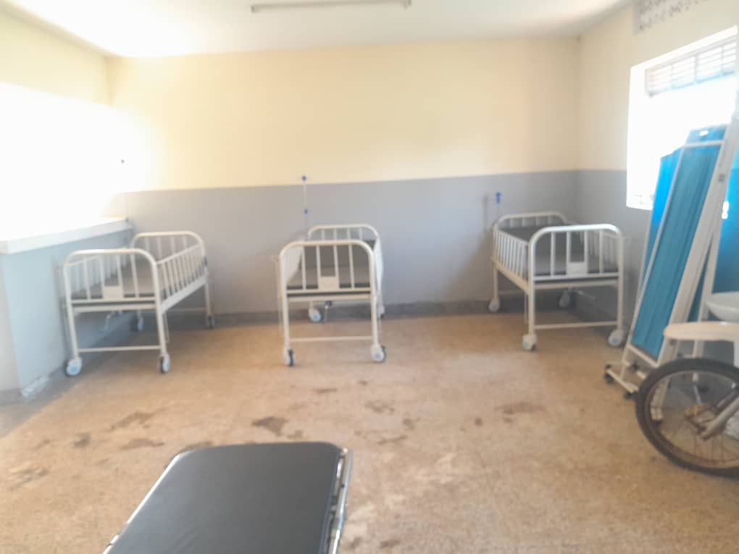
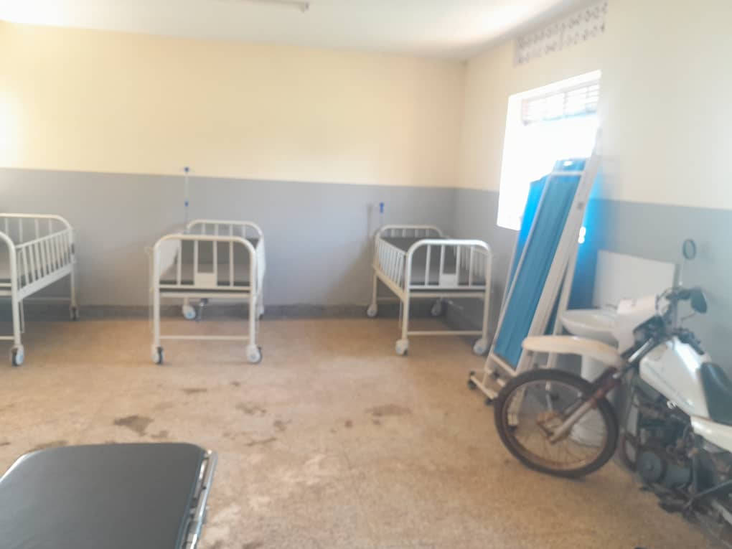
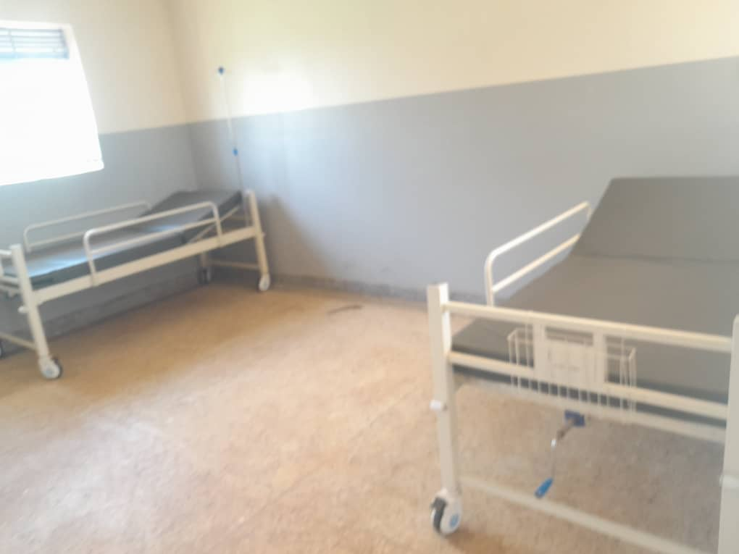
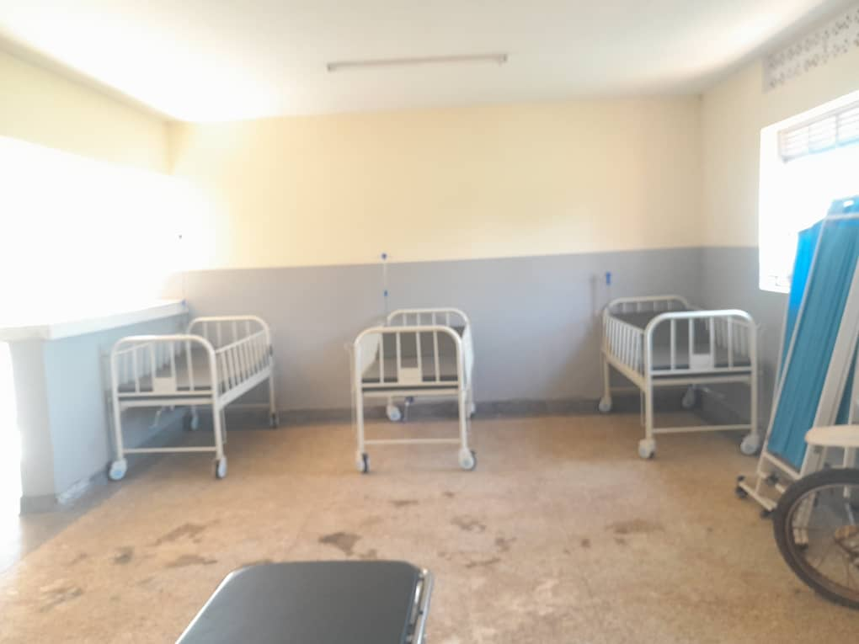
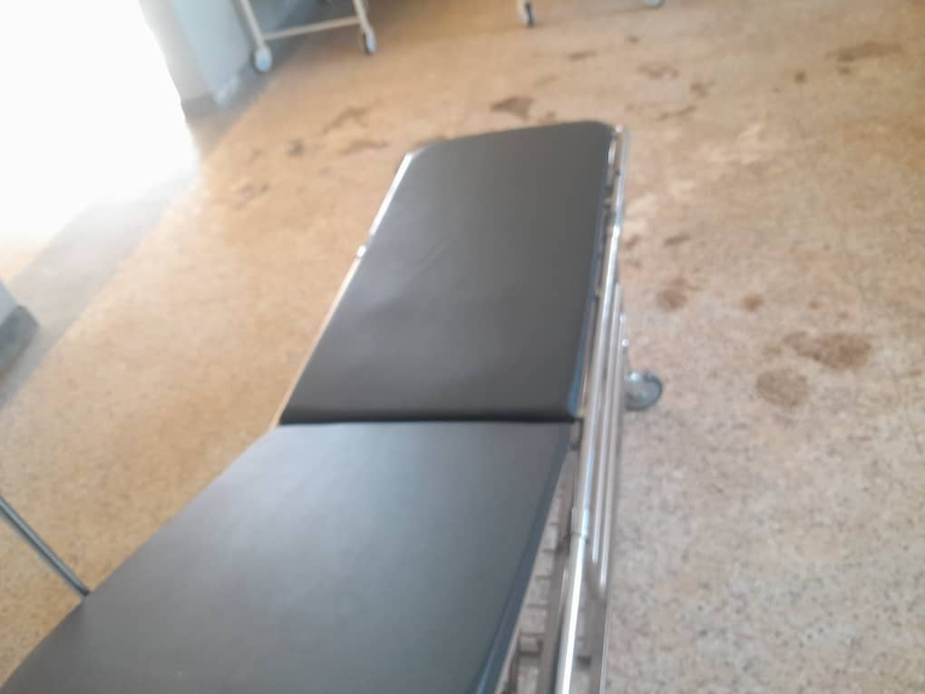
LAMIYO SEED SECONDARY SCHOOL, LAMIYO SUBCOUNTY IN AGAGO DISTRICT
information from the focal person in charge of the school. The in charge welcomed the team harmonically and managed to the us through the buildings of the facility which are still under construction.
FINDINGS: SCHOOL FURNITURE
The school have not yet received the school furniture because it is still under construction
SCHOOL BUILDINGS
- 3 Blocks of classes, each block has two classes equivalent to 6 classes
- 1 Block of science laboratory with two science rooms with stores.
- 1 Block with ICT laboratory and library.
- 1 Block with school offices and staff room
- 1 Multi -Purpose hall equivalent to 3 classes
- 3 Staff housing Block, each block has 2 house units
- 3 Staff kitchen blocks and each block has 2 kitchen units
- 3 blocks of staff quarters toilets and toilet has two stanzas
- 1 school football pitch not yet constructed
- 2 school toilets that is 2 for the student both girls and boys each with 5 stanzas
- 1 toilet is for school staff with 2 stanzas
NB: The above buildings are not complete still under constructions.
ICT DEPARTMENT
- 1 D-Link 4G router
- 1 Deluxe computer patch code m
- 1 D-Link patch code BM
- 25 CommScope dell data point
- 1 Yellow HJE optical perplex patch code
- 6 floor trucking’s
- 2 D-link cat 6
- 20 Dell desktop core I5, *GB and 20 inches
- Dell Desktop server core i7220TB
- 1 Olins F1026-L2NGINGA.pce
- 1 Hp laser jet MFP-410 DW printer
- 1 Epson Projector
- 1 Projection Screen 200x2000
- 1 D-link wireless router
- 1 LHIQ Air conditioner
- 20 Light wave ups 650 VA
- 1 Smart APC Server UPS
- 1 HIK vision fish camera
- 1 HIK- vision and channel NVR
NB: All the ICT assets are still in the stores of the district headquarters of AGAGO District.
CHALLENGES
- Delay in Construction
- Unreliable water supply
- Unreliable power supply
RECOMMENDATIONS
- Review the constructors of the construction
- Provide reliable water source
- Provide reliable power supply

IMAGES FROM THE SCHOOL
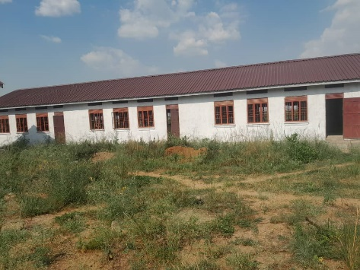
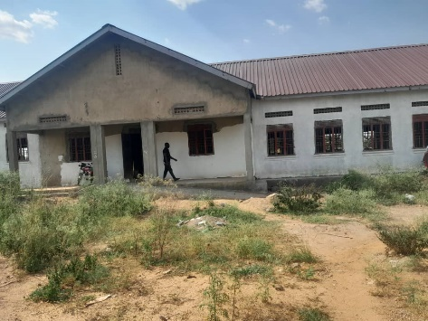
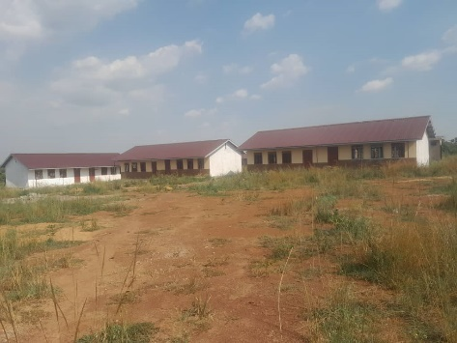
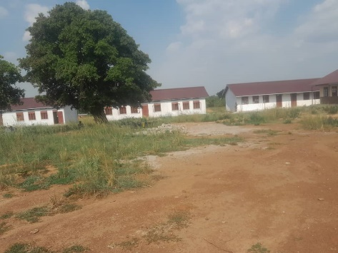
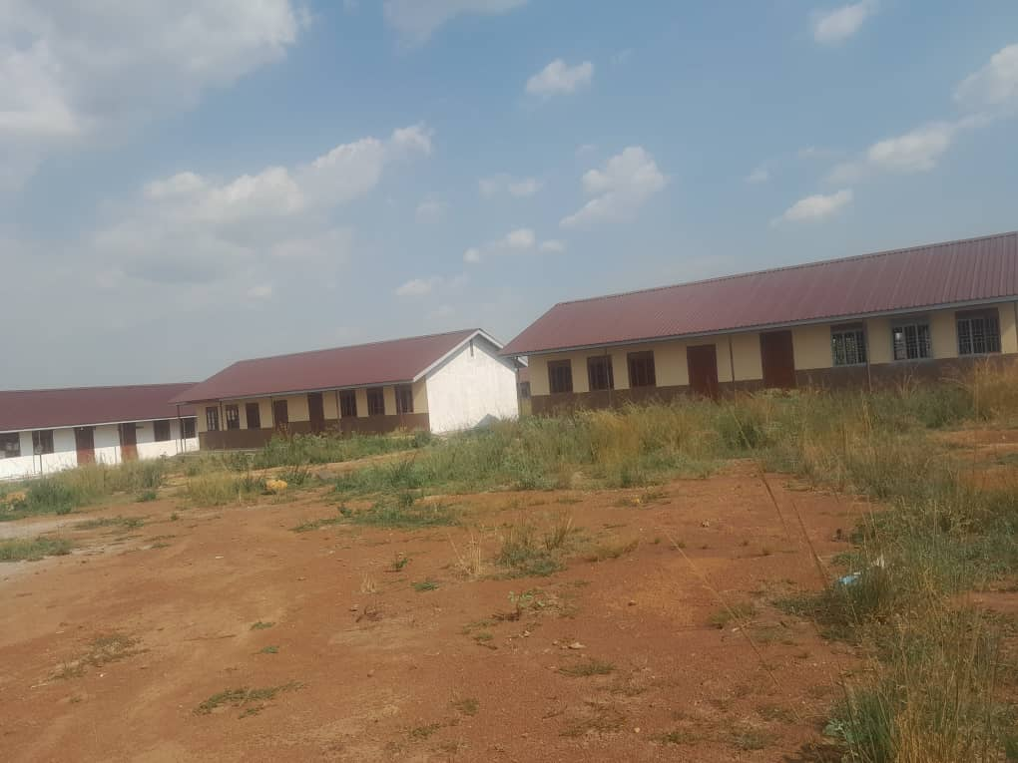
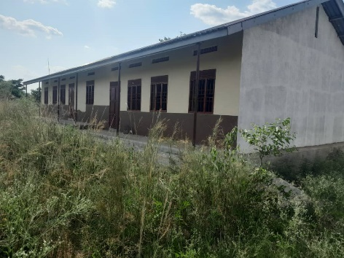
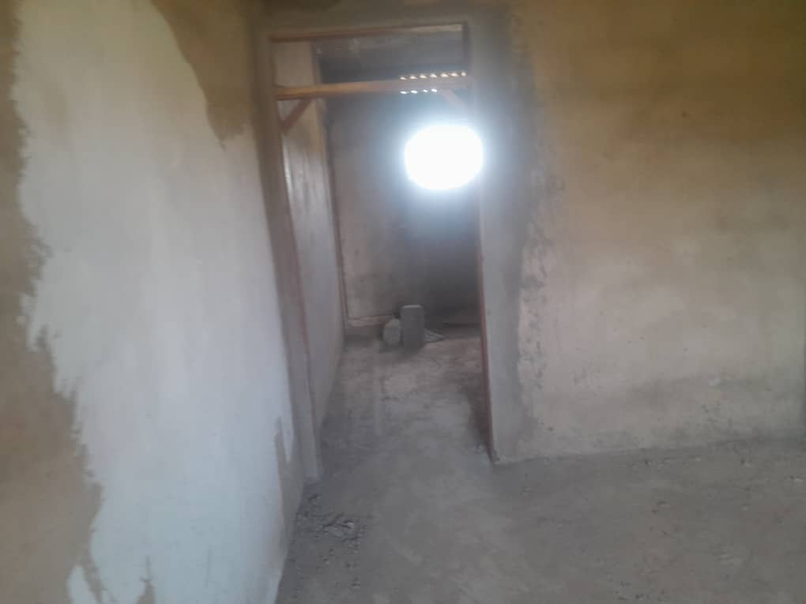
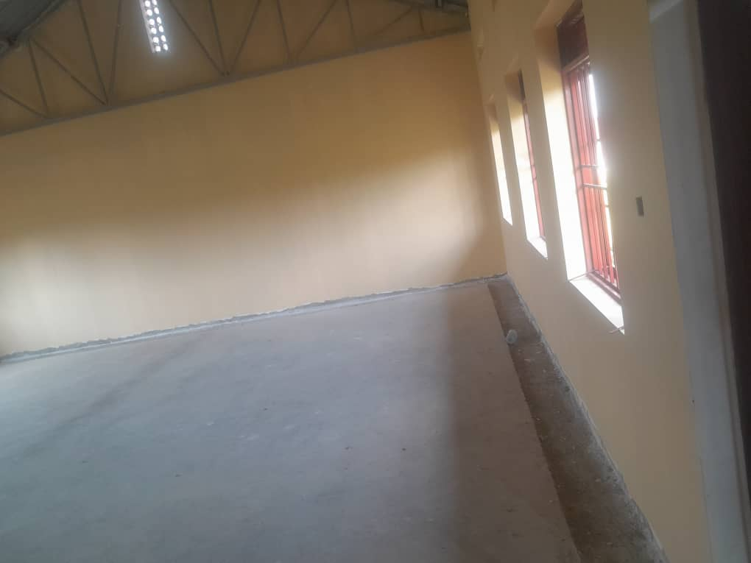
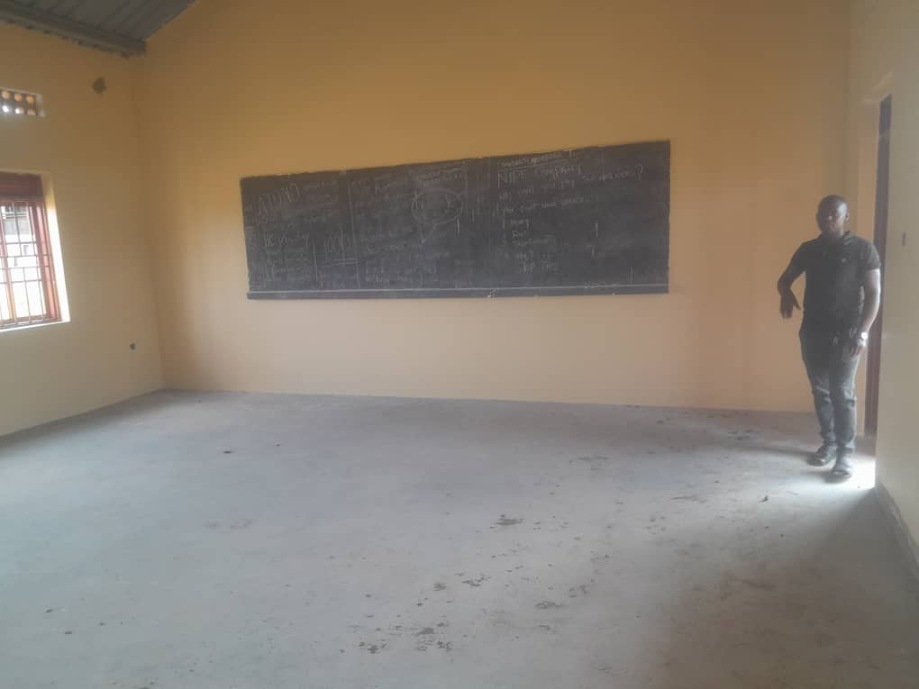
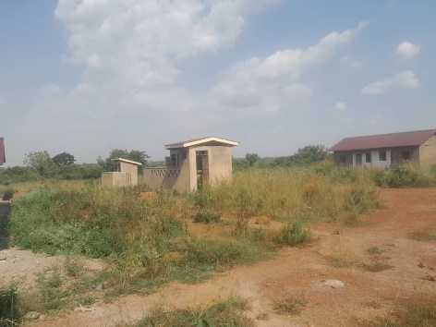
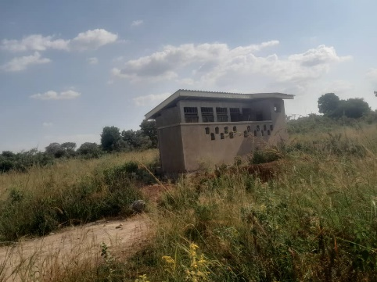
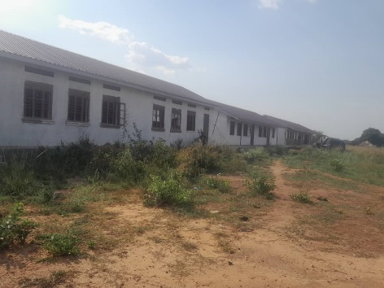
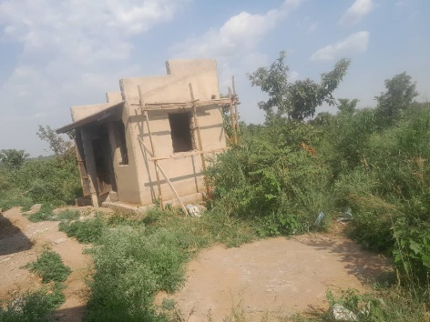
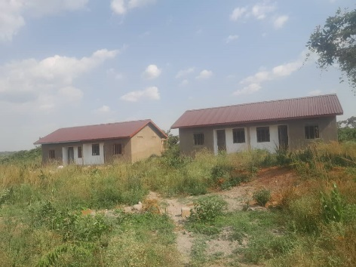
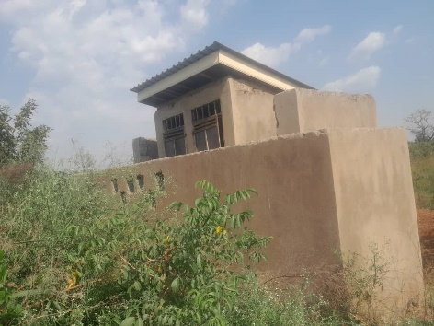

OMOT HEALTH CENTRE III IN OMOT SUB COUNTY – AGAGO DISTRICT
Information from the person in charge of the facility
The in charge warmly welcomed the team and proceeded to take the team through what so far the facility has benefited from the UGIFT Programme

FINDINGS
BUILDINGS (NON-RESIDENTIAL)
- 1 Maternity ward building
- Received only 10 beds without mattresses
- 1 Toilet with 4 stanzas
- 2 water tanks not connected
(RESIDENTIAL)
- 1 Block with two staff houses
- 1 water tank but not connected
- Staff toilets are not constructed.
NB: All are incomplete and are substandard done. This is evidenced with the attached photos
CHALLENGES
- Under Staffing
- Unreliable water source
- Power Problem
- Have no staff toilets
- Delay in implementations
- Beds have no Mattresses
RECOMMENDATIONS
- Employ more medical workers
- Provide reliable water supply
- Provide more beds with mattresses
- Build a staff toilet
- Provide reliable power supply
NB: All buildings need renovation both residential and non-residential because they are in a bad condition and are incomplete

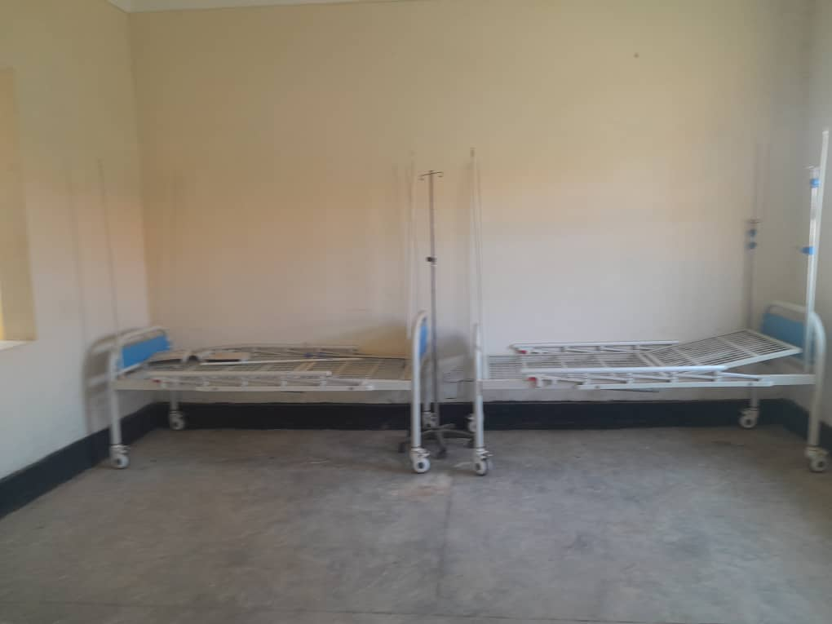
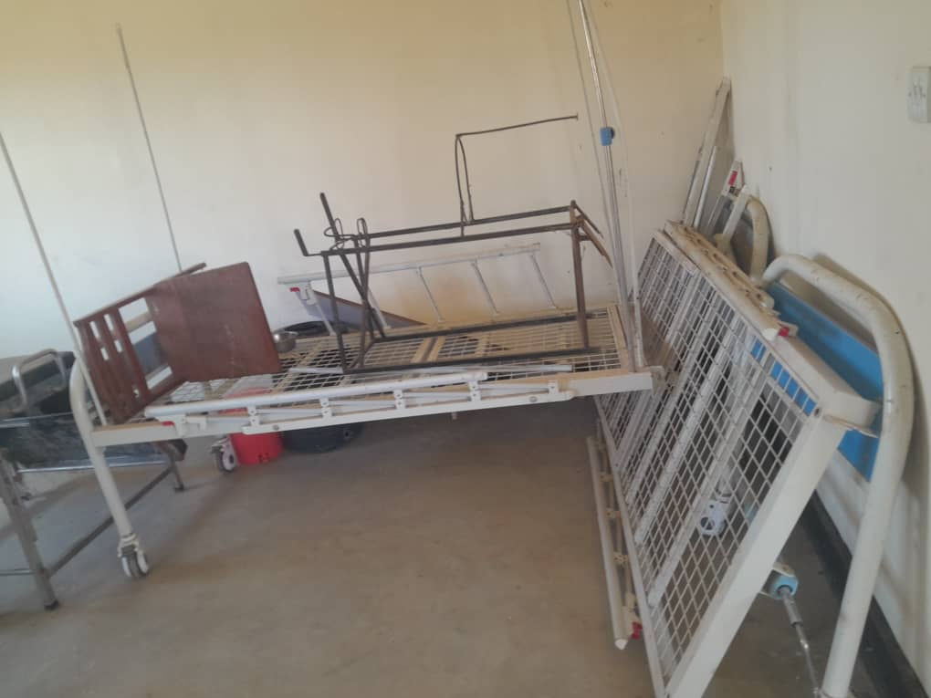
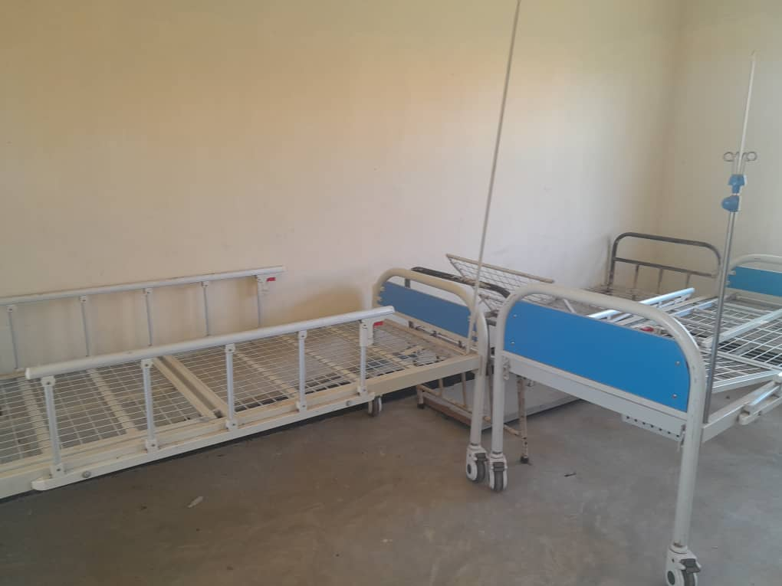
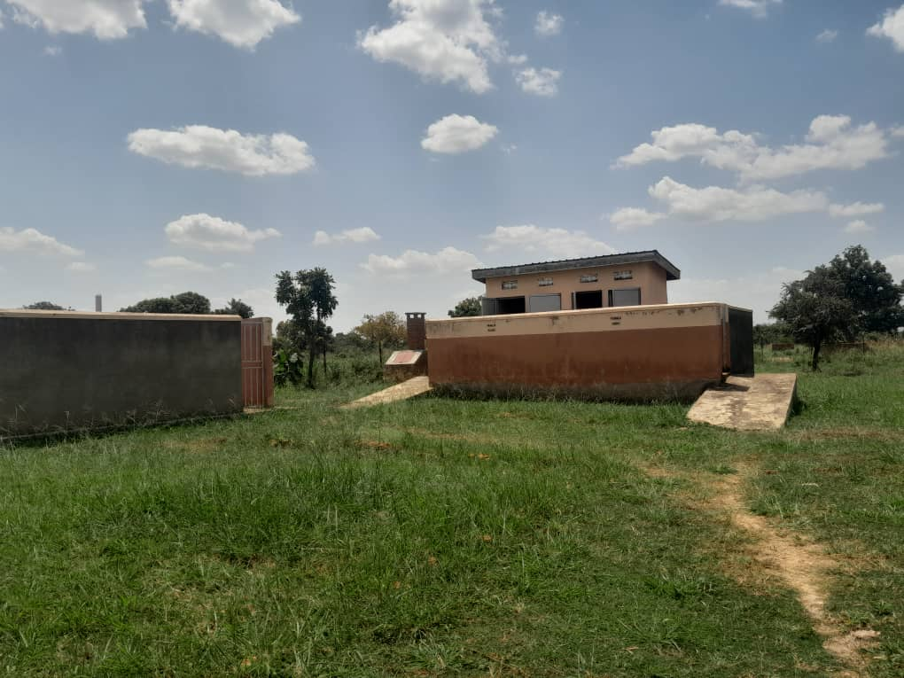
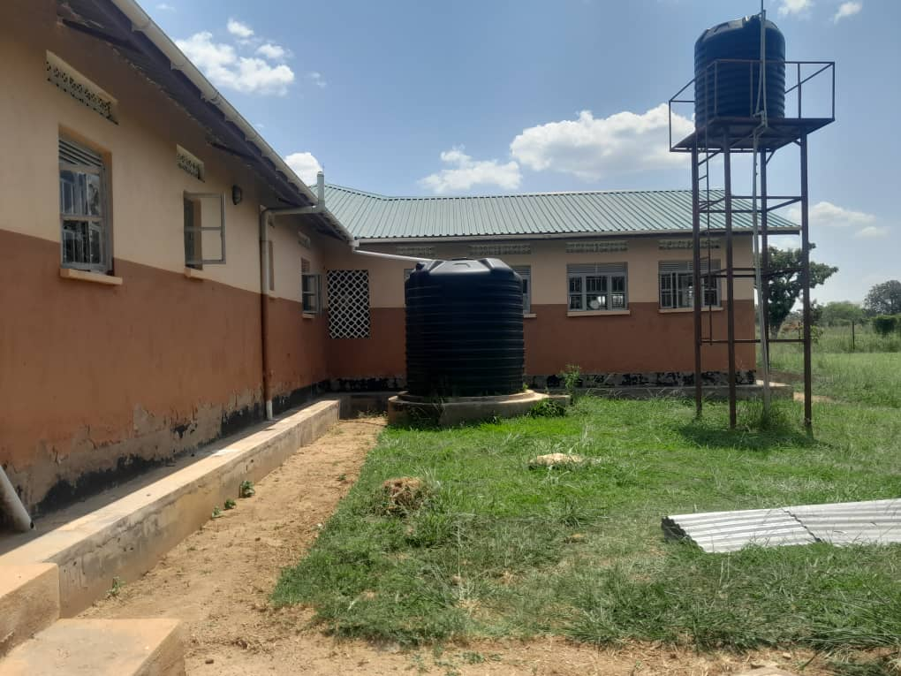
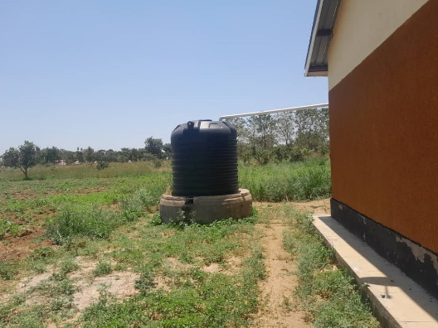
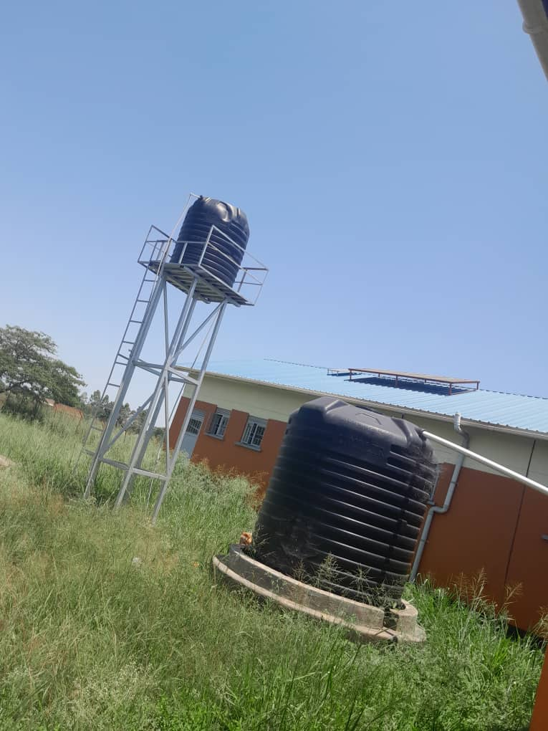
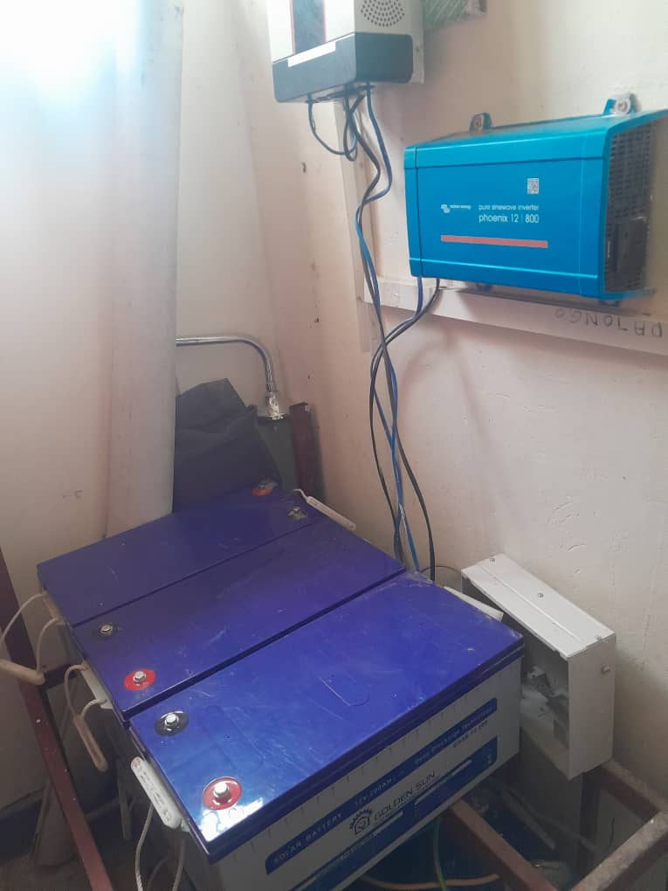
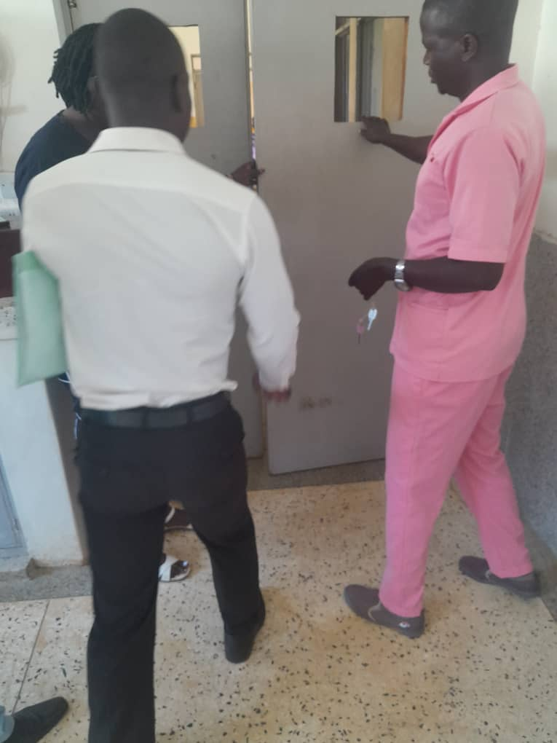
IMAGES FROM THE SOURCE

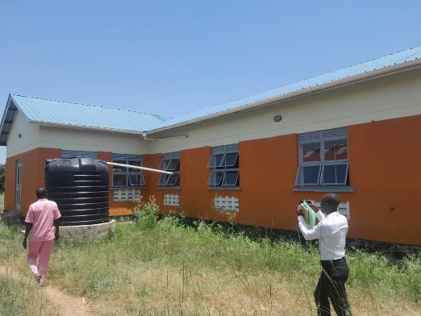
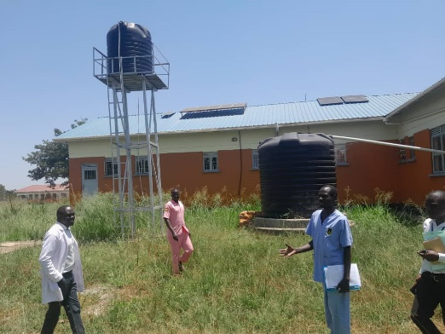
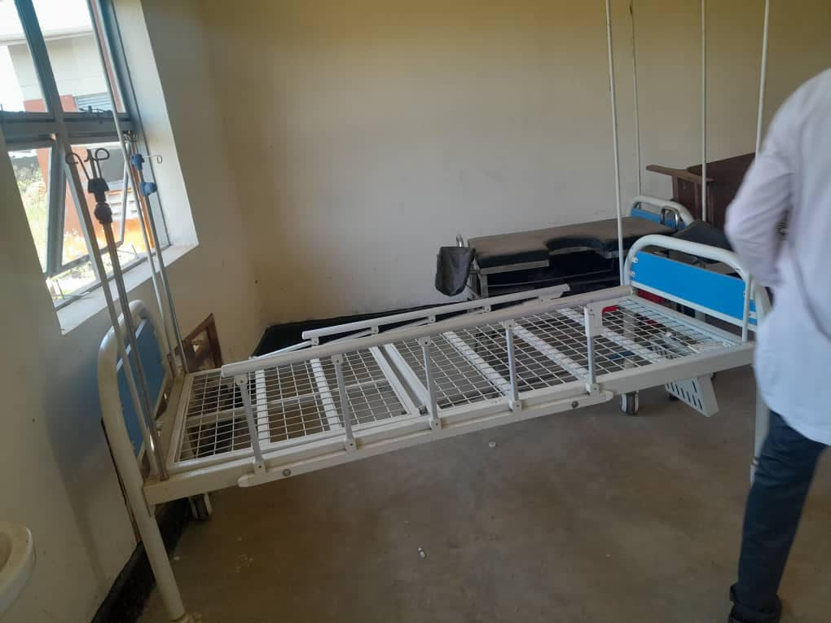

KOMOTOR SEED SECONDARY SCHOOL IN KOTOMOR SUB – COUNTY – AGAGO DISTRICT
The person in charge warmly welcomed the team and managed to take the team through what the facility so far received from the UGIFT Programme.

FINDINGS
- 3 Class blocks with 2 classes equivalent to 6 classes
- 3 Staff house blocks each with 2 staff house units
- 3 Staff Kitchen blocks each with 2 kitchen units
- 3 Staff toilets at the staff quarters each with Stanzas
- 3 School toilets, one for staff with 2 stanzas, 2 for students both boys and girls each with 5 stanzas
- 3 water tanks but not connected
- 1 football pitch but not completed
- School not fenced
- 1 science laboratory block with two science rooms
- 1 ICT Lab block with a Library
- 1 Multi-purpose hall equivalent to 3 classes
- The compound is not well grounded
NB: All the buildings are incomplete still under construction

ICT DEPARTMENT
- 20 Dell Desktop Monitors (SN.00CYGF-QDC00-482-0T41)
- 20 DELL UPS’s (SN.2411251006540, SN.2411251006539, SN.2411251006538, SN2411251006537)
- 1 Solar Panel
- 1 HP Printer (SN.CNCRS40S.NF)
- 1 Camera Decorder (SN. FV0427680)
- 1 Camera HIK Vision (SN. FT018388)
- 1 Air Conditioner Dell (SN-G3A901514061800M)
- 2 D-Link (SN-QSAQ22A003115)
- 2 Wires Router (SN-22371J1012022)
- 1 Epson Projector
NB: All the ICT Equipment for KOTOMOR Seed School are still in the district headquarter stores.
FURNITURE
- 59 Metallic and top Wooden
- 70 Wooden Desks
- 93 Chairs Metallic with Seat and back wooden.
CHALLENGES
- Delay in completing of the facility
- Lack of power supply
- No reliable water sources
- Water tanks not connected
RECOMMENDATIONS
- Review the constructor to complete the facility
- Provide Power Supply
- Provide reliable water sources
- Connect the water tanks
NB: The buildings are substandard built and in short time of use they will all need renovation. The facility is still under construction.

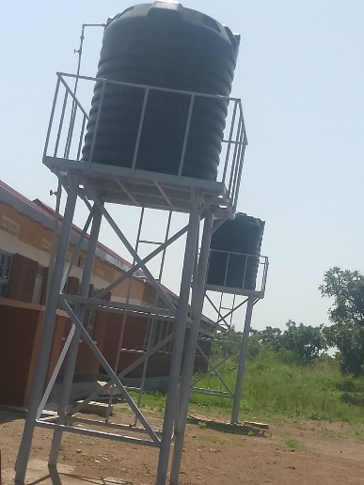
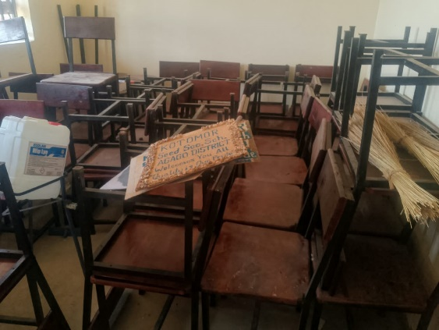
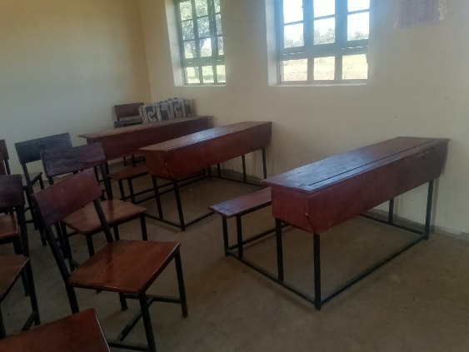
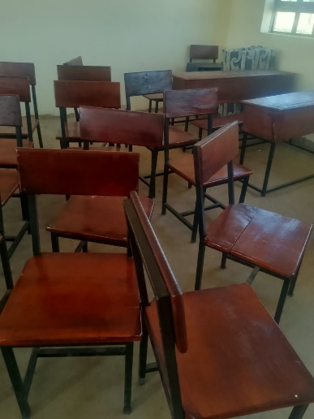
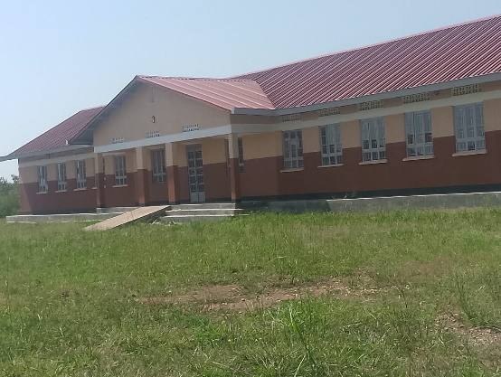
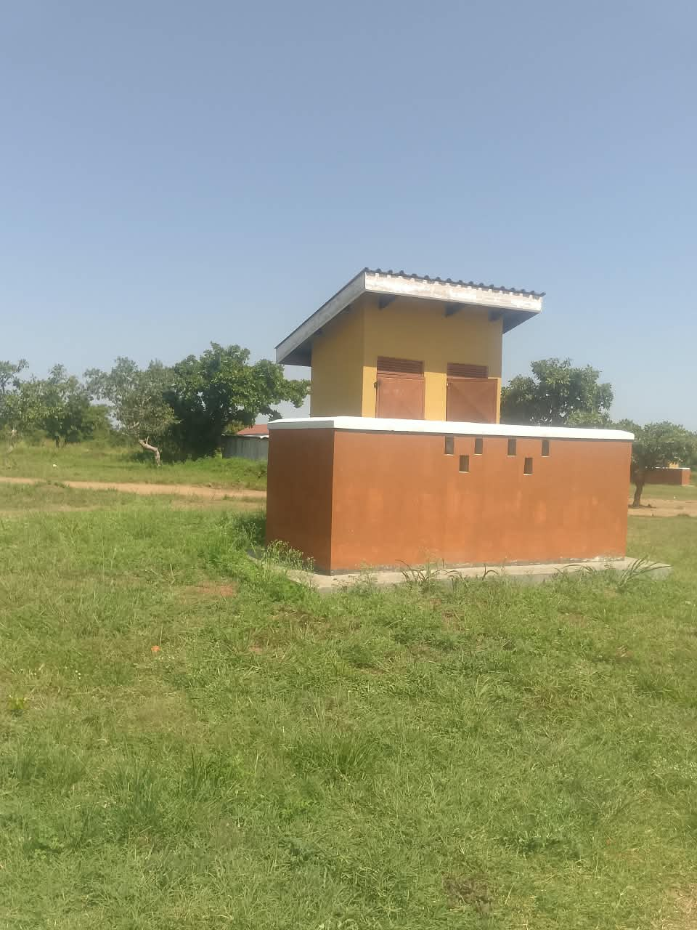
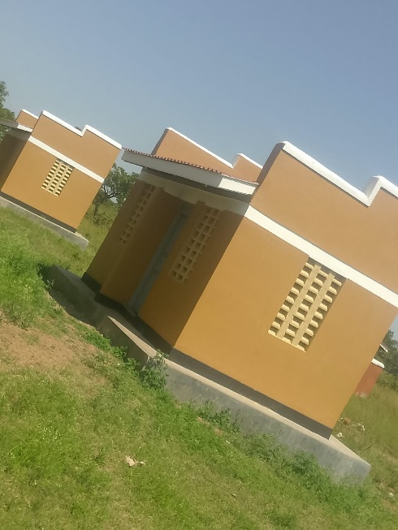
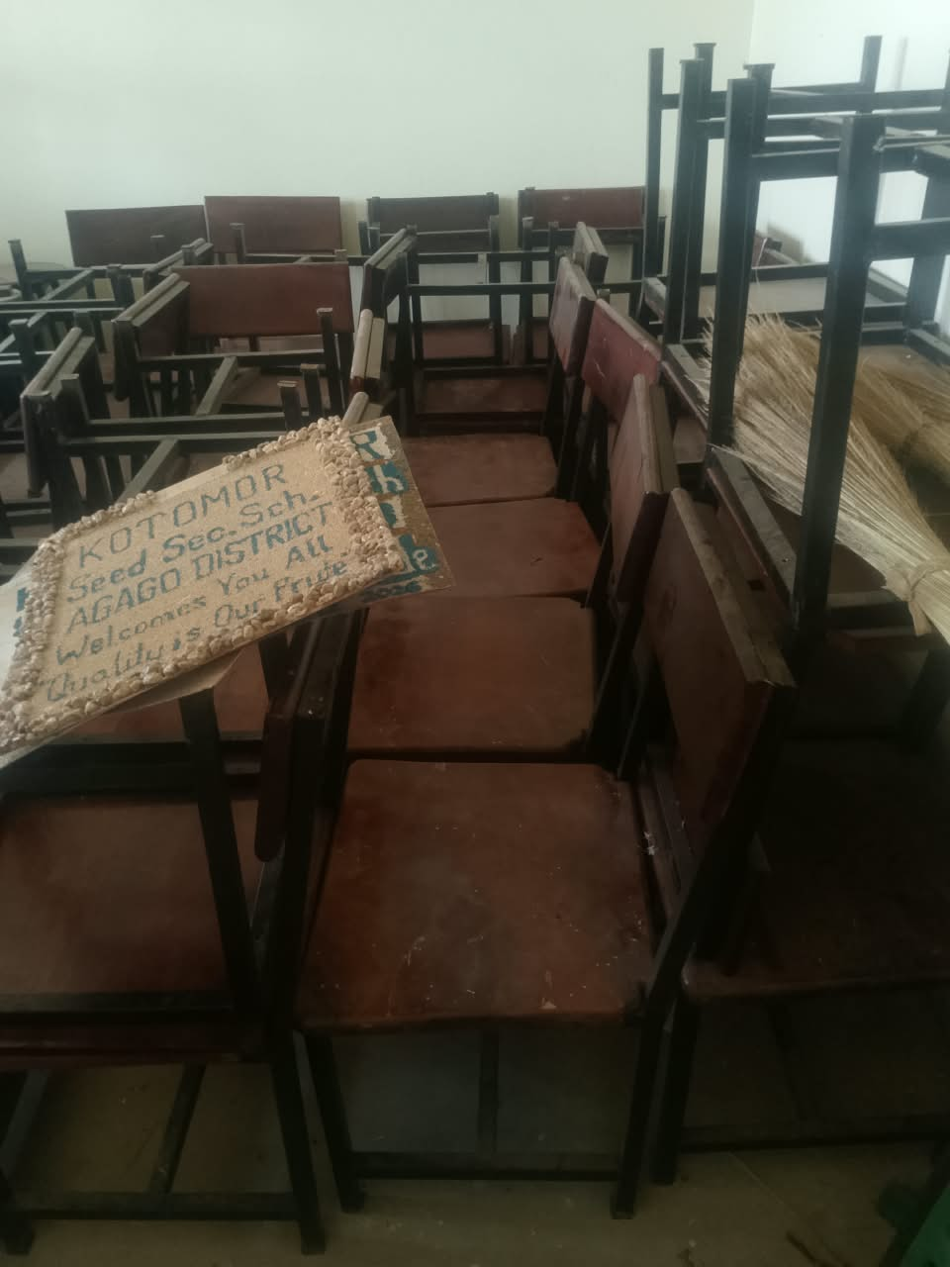
IMAGES FROM SCHOOL
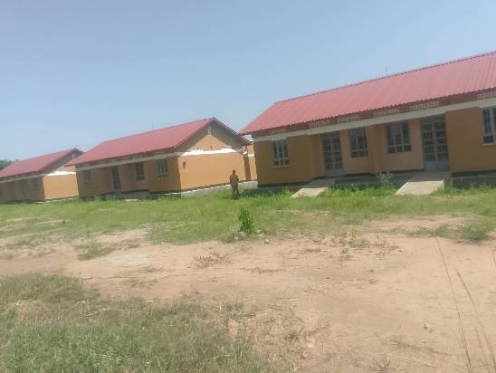
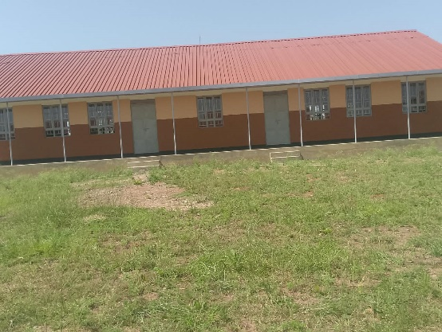
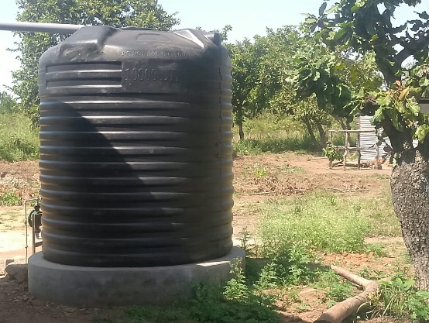
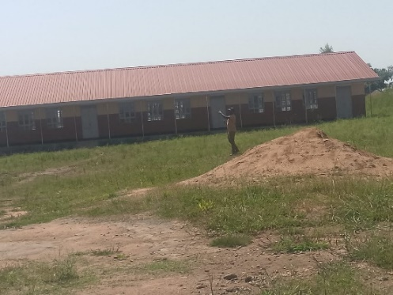
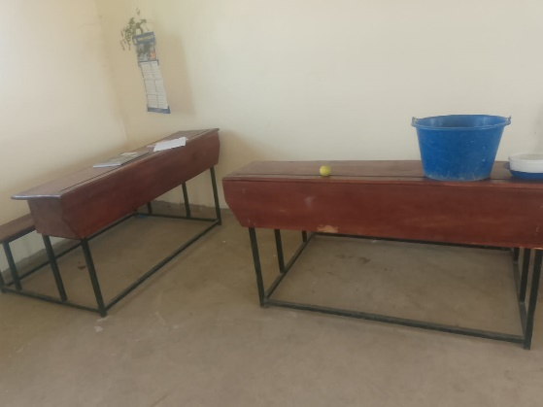
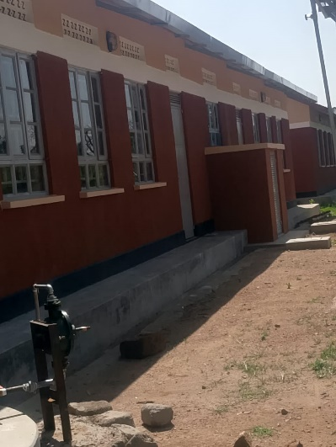
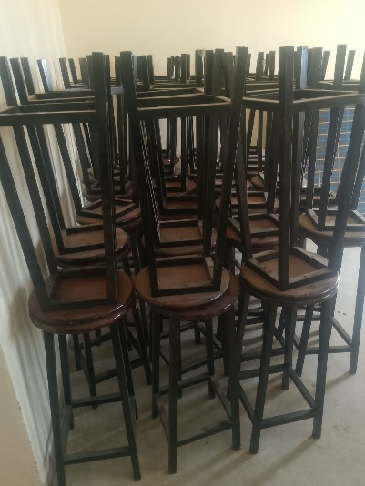
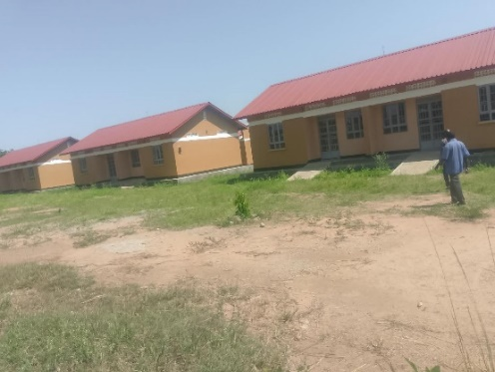
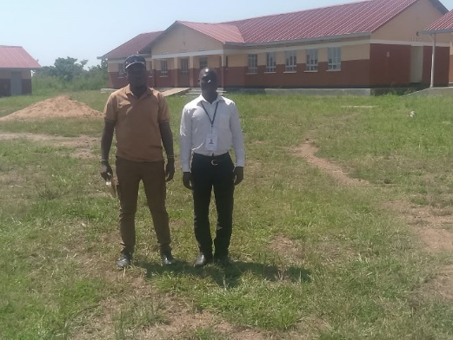
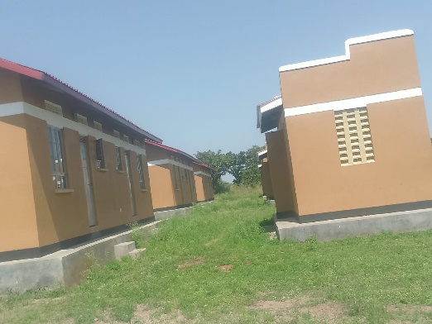
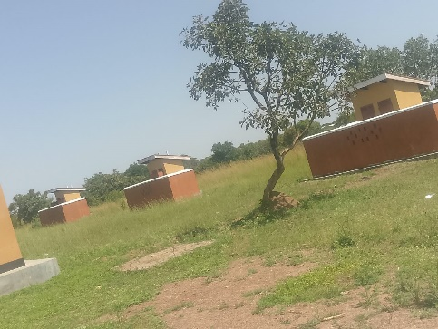
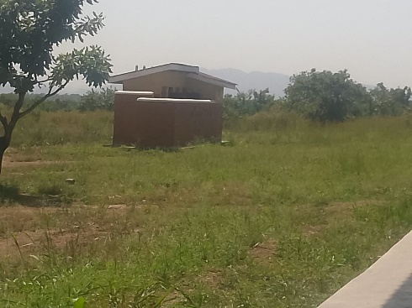
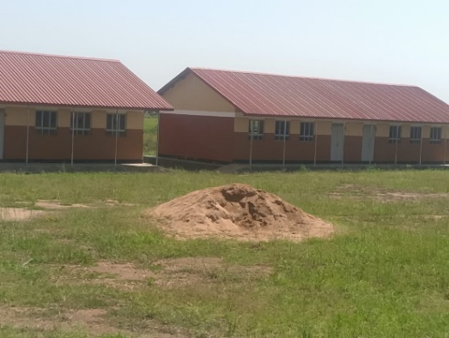
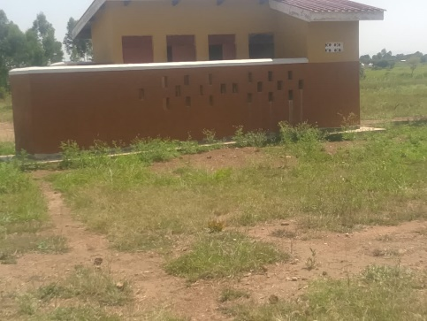
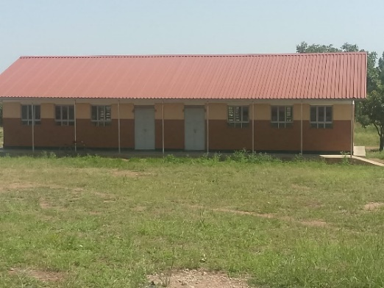
AWOL SEED SCHOOL, AWOL SUB-SCOUNTY – AGAGO DISTRICT
The team was warmly welcomed by the in charge of the facility and he took us in his office where we had a brief conversation about the UGIFT Programme, how the facility particularly has benefited and the community at large.
The in charge managed to take us through so far what they have benefited from the UGIFT Programme and theses are evidenced as below in the attached photos.

FINDINGS
- The completed facilities have significantly improved the learning environment and enhanced the school’s capacity to provide quality education services.
- Incomplete works and defects identified despite the progress made the following issues require attention
- The school playing ground has not been completed.
- There are noticeable wearing and damages to the floor surface Infront of the staff room and the main administration office
- The moveable partition shatters in the multi-purpose hall are made out of plywood and they are easily broken down.

FURNITURE
No. | Items | Number Supplied | Number Missing | Totals
1 | Desks | 102 | 18 | 120
2 | Tables | 130 | 09 | 139
3 | Chairs | 241 | 23 | 264
5 | Lab Stools | 121 | 03 | 124
5 | Book Shelves | 19 | 01 | 20

BUILDINGS
The following facilities have been substantially completed
- 6 Class rooms
- Administration block with offices and staff room
- ICT and Library block
- Multi-purpose hall equivalent to 3 class rooms
- Science laboratory block
- 3 Staff kitchen block each with two kitchen units
- 3 Staff toilets each with 2 stanzas
- 2 student toilets for both girls and boys each with 5 Stanzas
- 1 Staff toilet at school with 2 stanzas

ICT DEPARTMENT
ICT assets were delivered on 3rd August 2026.
- 20 Desktop Key boards (SN:9CTHz30BRK)
- 20 Hp Desktop Monitors (SN-HP5kEH68503)
- 20 Hp Desktop UPS (SN. HCE433D7B2/SN.4CE433D77CC)
- 1 Air Conditioner but not installed
- 1 Server
- 1 Camera
CHALLENGES
- Delay in the completion of the work
- Computers not yet installed
- The Facility not fenced and is exposed to insecurity.
BENEFITS
- Parts of the facility are being used
- Improved education services in the area.
- Quality education services are easily accessible by the students in the area.
RECOMMENDATIONS
- Call back the contractors to complete their incomplete work
- Provide reliable water supply and power supply
- Renovate the buildings that were substantially done.

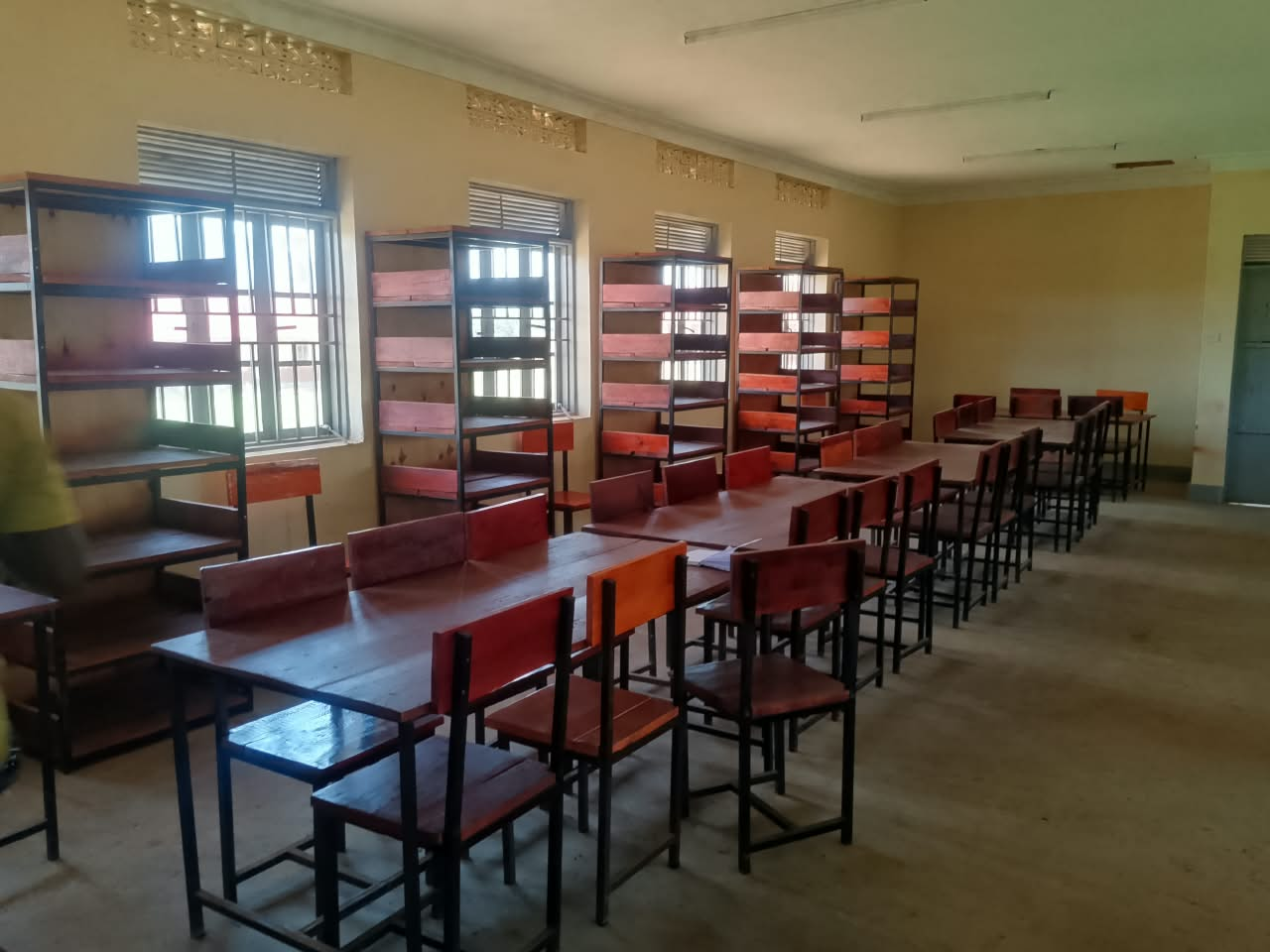
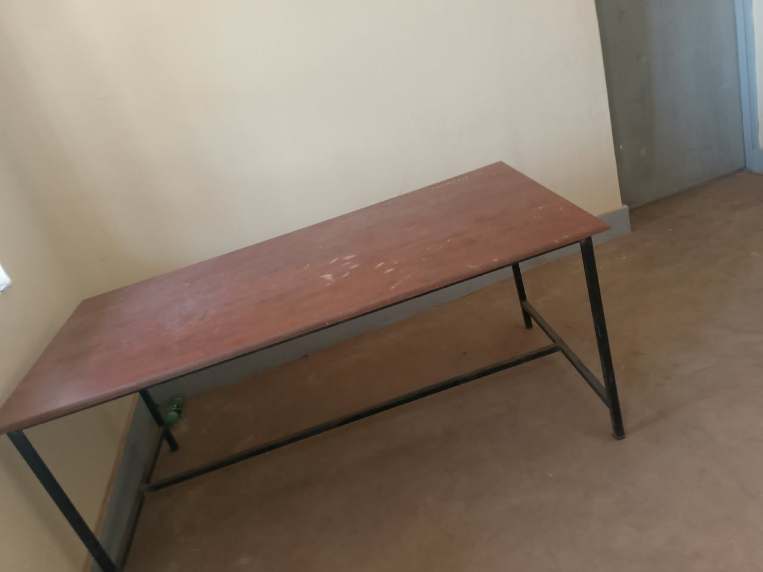
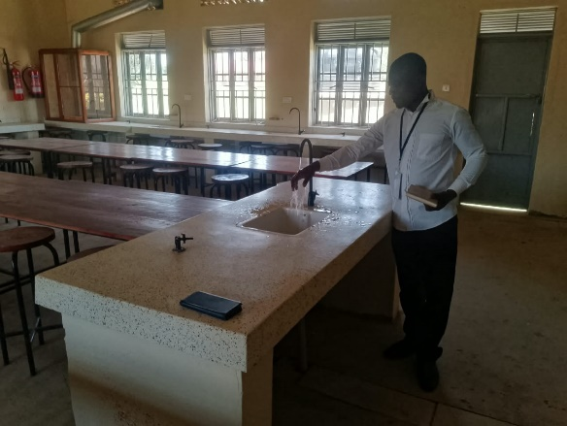
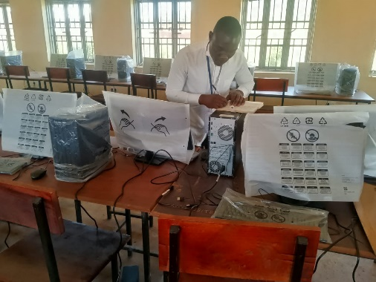
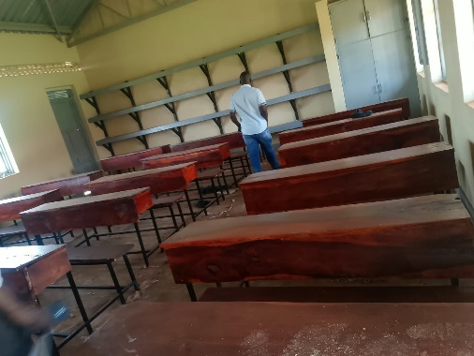
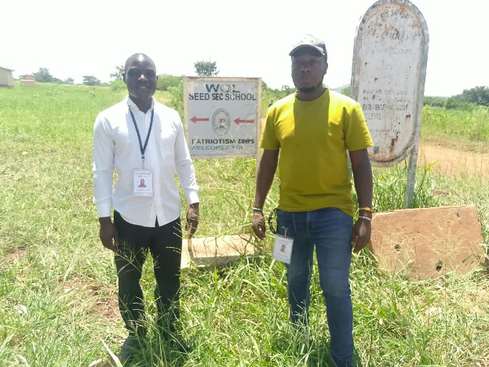
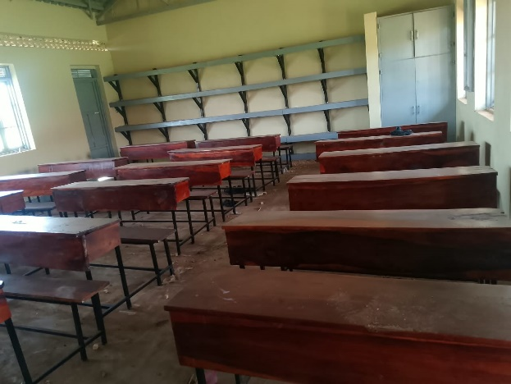
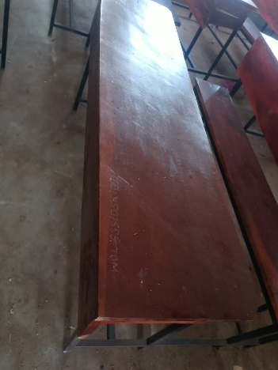
IMAGES FROM THE SCHOOL.

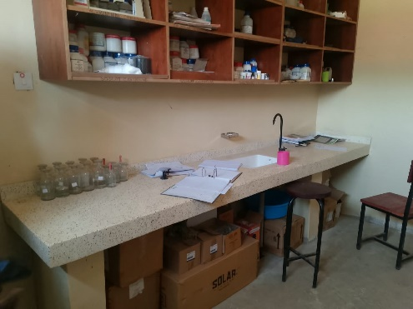
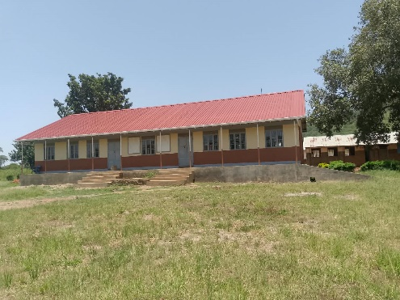
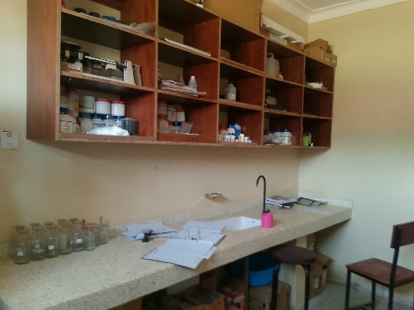
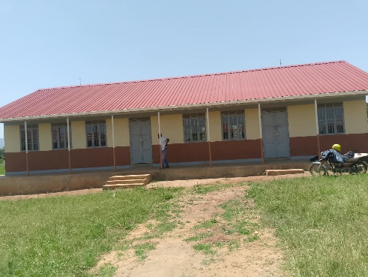
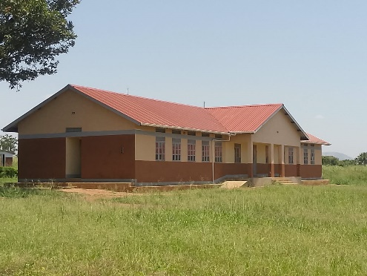
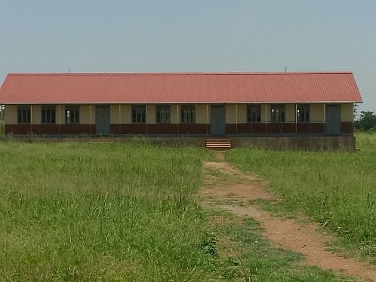
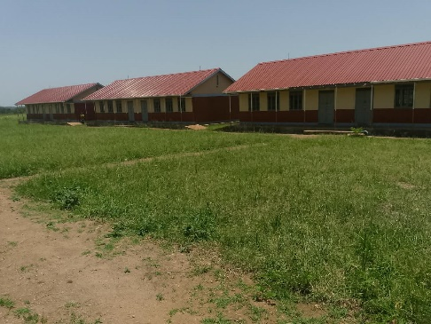
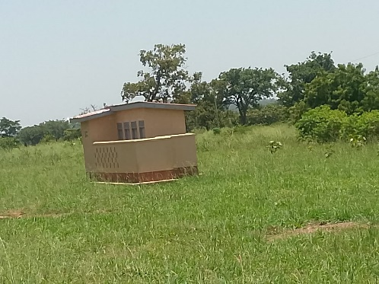
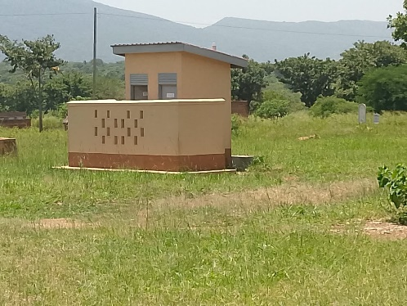
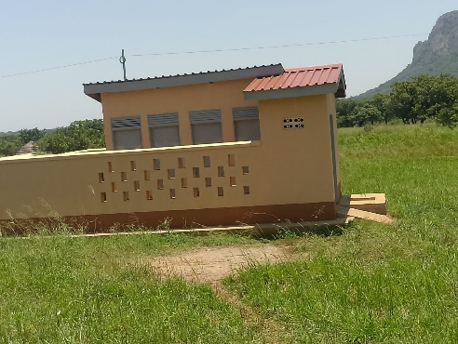
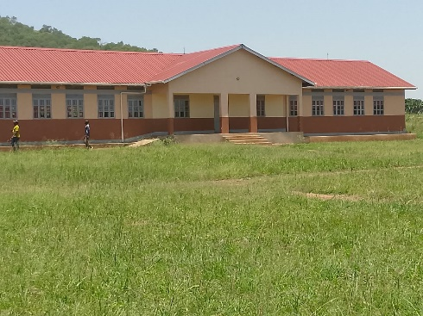
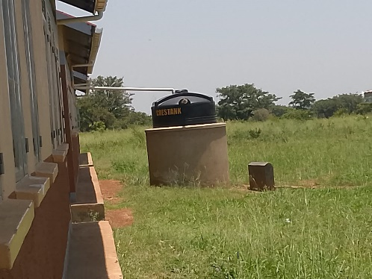

Report By:
Akwankwatsa Edwin
Tel: 0702527069
Email: piaedie@gmail.com

